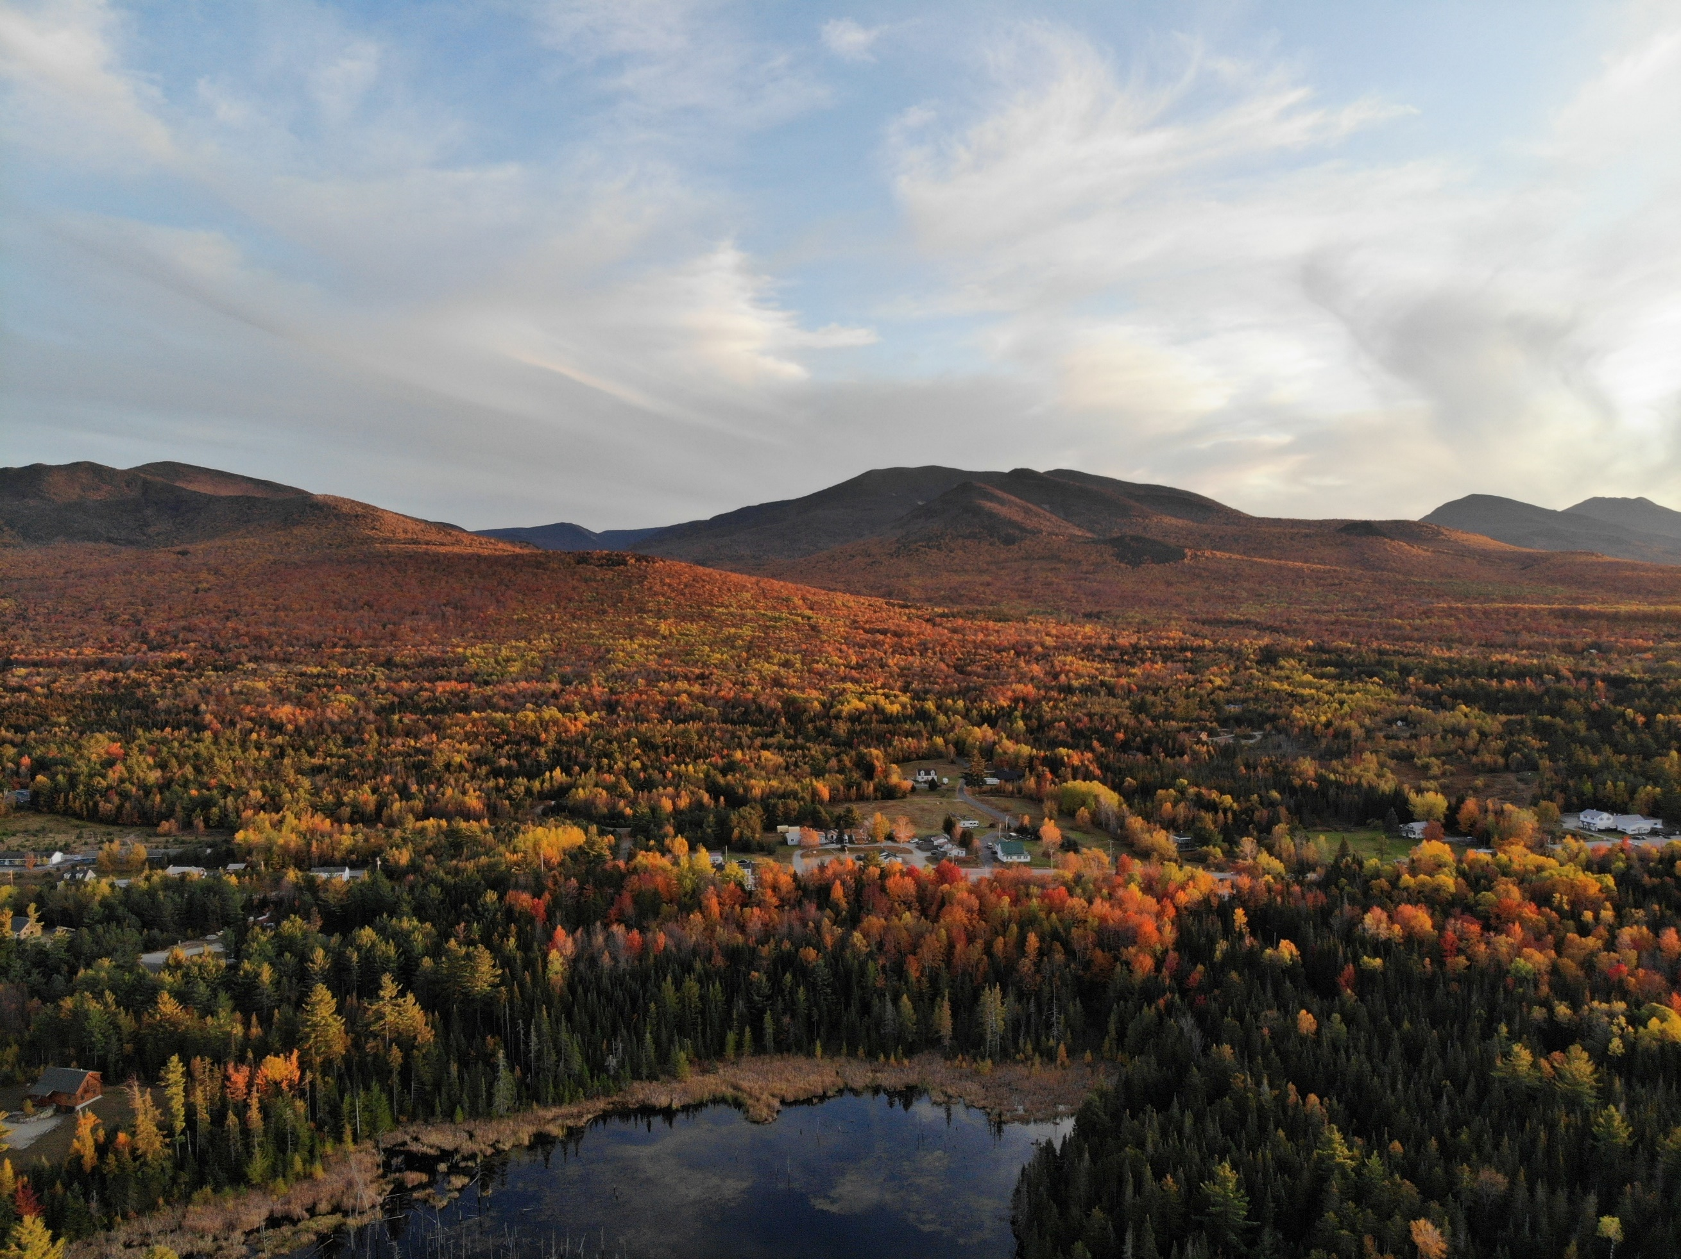
Town of Carroll Master Plan
June 2025

Table of Contents
Vision 1
Introduction 3
Accommodations 4
Overview 4
Carroll Demographics 4
Housing Cost 6
Housing Supply 8
Residential Types 9
Housing Needs 10
Building Business 12
Overview 12
Economic Growth & Development 12
Working in Carroll 13
Doing Business in Carroll 16
Connecting Carroll 18
Overview 18
Traffic and Commutes 18
Municipal Buildings and Services 21
Infrastructure 23
Energy 26
Tourism 27
Tips for Supporting Municipal Connections 28
Designing Our Community 29
Overview 29
29
Land Use in Carroll 30
Future Land Use 32
Town Character 34
Town Services and Programs 35
Community Programs and Events in Carroll 36
Environmental Stewardship 38
Introduction to Carroll’s Environment 38
Outdoor Recreation 39
Weather and Climate 41
Protecting and Preserving the Environment 44
Rare and Threatened Species 44
Habitat Distribution and Protection 45
Surface Water Systems 49
Groundwater & Municipal Supply 49
Water Quality Threats 49
Implementation Strategy 51
Appendix A – Data 61
Population Trends 65
Median Household Income 69
Industry & Employment 71
Transportation 73
Average Daily Traffic 73
Vehicles Available by Household 75
Commuting to Work 75
Housing 76
Housing Occupancy, Vacancy, and Unit Type 76
Income and Housing 77
Short Term Rentals 79
Building Permits 80
Appendix B – Maps 82
Appendix C – Resident Survey Response 92

Vision
The Town of Carroll envisions a future where its rural charm, natural beauty, and tight-knit community thrives alongside sustainable growth within the hospitality industry. The Town’s Vision is to embody resilience, inclusivity, and innovation and be a place where residents of all ages and incomes can live, work, and play in harmony with the environment. The following five mini-vision statements are essential components of this overall vision for Carroll’s future.
- A Community Rooted in Home
- Affordable, Accessible Housing: Expand housing options—from single-family homes to mixed-income rentals and units for older adults—through partnerships with developers, zoning enforcement and changes, and incentives.
- Balanced Seasonal and Year-Round Needs: Prioritize year-round housing while respecting seasonal visitors.

- Economic Vitality with Local Character
- Business Growth & Support: Foster a thriving local economy by streamlining the permitting process for small businesses, supporting existing businesses, and identifying compatible businesses that complement the existing ecosystem.
- An Inviting Town Center: Transform Main Street into a walkable hub with benches, public art, and events, while preserving the quaint historic architecture and small town feel.

- Safe, Sustainable Infrastructure
- Modern Roads: Modernize roadways to be more walkable and bikeable.
- Resilient Utilities: Upgrade water/sewer systems using green infrastructure.
- Clean Water & Renewable Energy: Protect aquifers through conservation easements, promote low-impact development, and promote municipal and private renewable energy use.
- Zero-Waste: Expand and encourage reduction, recycling/composting programs.

4. Connected, Inclusive Community
- Enhanced Facilities & Services: Build a community center that offers diverse programs, while upgrading parks, libraries, and broadband connectivity.
- Vibrant Social Fabric: Organize year-round activities that unite residents from all areas of Carroll and attract visitors.
- Collaborative Governance: Engage residents via annual town events and digital tools to ensure transparency and adaptability.
5. Stewards of Nature & Resilience
- Protected Ecosystems: Preserve forests, wetlands, and wildlife corridors through conservation zoning and partnerships with land trusts.
- Climate-Ready Carroll: Implement floodplain management, fire-resistant landscaping, and emergency preparedness hubs to reduce disaster risks.
- Recreation for All: Expand trails, river access, and adaptive outdoor programs while balancing tourism with ecological protection.
- Sustainable Development: Encourage attractive compact, efficient building designs in designated growth areas, preserving 70% of Carroll’s land as open space.

Introduction
The Town of Carroll stands at a pivotal moment—balancing the preservation of its cherished rural character with the opportunities and challenges of a changing world. The 2025 Carroll Master Plan is a blueprint for the future, crafted to guide thoughtful development, protect natural treasures, and foster a vibrant, connected community while welcoming tourism.
This Master Plan was developed over an 18-month period beginning in 2024 and wrapping up in June of 2025. The Town’s efforts were led by a Master Plan Subcommittee and the Carroll Planning Board, with the assistance of North Country Council. Over that time period, the Town conducted a survey (see Appendix C), held a Community Open House, consulted with Department Heads and met monthly from March until June 2025 to ensure the Chapter content, Goals and Strategies would accomplish the Vision for the Town.
The Master Plan was organized based on feedback from the residents. The Plan is broken into five Chapters that represent the Carroll’s priorities:
- Accommodations: Demographics and Housing
- Building Business: Employment, Businesses in Carroll, and Economic Development
- Connecting Carroll: Transportation, Town Services and Buildings
- Designing Carroll: Land Use, Development Patterns, and Programs that Support Residents
- Environmental Stewardship: Outdoor Recreation, Conservation Land and the Natural Environment
The final components of the Master Plan are the Implementation Strategy and the Appendix. The Implementation Strategy includes Goals and Actions for each of the 5 Chapters, including the status of the Action, who to partner with to achieve the Action and whether it requires a zoning change. It is available as an Excel spreadsheet so the Town can regularly assess progress and determine what the priorities are for each of the partners. The Appendix includes all of the data and maps completed by North Country Council and the results of the survey conducted in late 2024.
The data included in this Master Plan are meant to be a snapshot in time. It is recommended that this data be revisited to ensure decisions are based on the most up-to-date information available.

Accommodations

Overview
The Accommodations Chapter of the Carroll Master Plan addresses the critical housing issues facing the town. In recent years, Carroll has experienced significant challenges related to housing affordability and availability, which have hindered growth both locally and regionally. This chapter will discuss housing supply and cost, housing needs, and how partnerships and zoning updates can play a role in increasing the supply and affordability of housing in Carroll. The chapter emphasizes the importance of addressing both current and future housing needs to ensure sustainable growth and community development in Carroll.

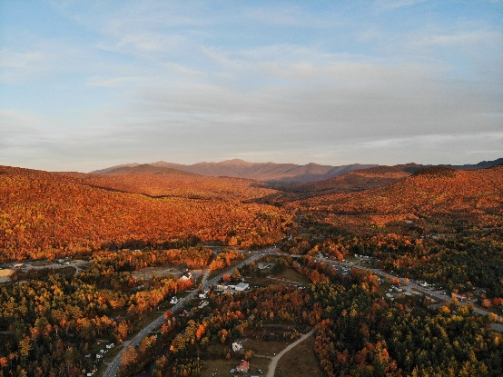
Carroll Demographics
Photo Credit: Town of Carroll, 2025
The Town of Carroll has the oldest median age in the surrounding area and Coos County region (see Figure 1). As ages increase, there are fewer suitable housing choices and services available. This was also recognized by Carroll residents when 26% of respondents said they needed senior housing, and 34% said they would support it. In Carroll, owner-occupied housing units have an average household size of 1.8 people, which indicates that most residents do not need large homes. Even those renting have a small average household size of 2.39 people (see Table 1). One potential solution is to increase different housing options, allowing older residents to downsize while freeing up larger homes for younger and larger families.
Table 1: Average Household Size for Owner and Renter Units in Carroll, 2010-2022
Owner or Renter Occupied | 2010 | 2020 | 2022
Owner-Occupied | 1.95 | 1.68 | 1.80
Renter-Occupied | 3.13 | 2.55 | 2.39
Source: ACS 5-Year Estimates (2006-2010), (2016-2020), and (2018-2022) | DP04

Figure 1: Median Age of Residents in Carroll and Other Locations, 2010-2022
Source: US Census ACS 5-Year Estimates (2006-2010), (2016-2020), and (2018-2022) | DP05
Population growth and projections are important to understand when looking at potential and future housing needs. The current population of Carroll is 795 people (See Table 2). Since 2010, Carroll has experienced a slow but steady population increase. However, projections indicate that beginning in 2025 the population will begin to decline over the next decade. The decrease in population could impact community services and the long-term housing needs of Carroll residents.
Table 2: Population Change in Carroll and Other Locations, 2010 to 2022
Location | 2010 | 2020 | 2022 | % Change 2010 to 2022
Carroll | 608 | 773 | 795 | 31%
Coös County | 33,445 | 31,486 | 31,430 | -6%
Bethlehem | 2,493 | 2,591 | 2,512 | 1%
Littleton | 5,949 | 5,916 | 6,021 | 1%
Grafton County | 88,356 | 90,331 | 90,836 | 3%
State of NH | 1,313,939 | 1,355,244 | 1,379,610 | 5%
Whitefield | 2,220 | 2,141 | 2,484 | 12%
Source: US Census ACS 5-Year Estimates (2006-2010, (2016-2020), and (2018-2022) | DPO5

Housing Cost
In 2023 Carroll’s median home purchase price was $600,500 (see Table 3). Since 2020 the purchase price of homes has grown by 43%. Carroll’s median home purchase price is $182,000 more than the NH median of $418,000.
Table 3: Median Home Purchase Price in Carroll and Other Locations, 1990-2023
Location | 1990 | 2000 | 2010 | 2020 | 2023
Carroll | $80,000 | $79,950 | $169,500 | $420,800 | $600,500
Bethlehem | $79,900 | $90,000 | $135,250 | $208,800 | $249,500
Littleton | $105,048 | $88,000 | $139,200 | $200,000 | $300,000
Whitefield | $75,000 | $71,500 | $117,500 | $220,500 | $260,000
Coös County | $69,900 | $69,950 | $145,000 | $145,000 | $216,000
Grafton County | $104,000 | $104,000 | $185,000 | $231,000 | $355,000
NH | $119,905 | $143,000 | $215,000 | $302,300 | $418,000
Source: NH Housing Finance Authority, Purchase Price Trends, 1990-2023

Not only is the housing supply low but prices are unprecedentedly high, which creates challenges for people to afford their housing costs. Housing costs that exceed 30% of a household’s income is defined as being housing burdened. Cost-burdened is when the household spend more than 30% of their pre-tax income on housing expenses, including rent or mortgage payments and utilities. A household is considered severely cost-burdened if they spend more than 50% of their pre-tax income on housing costs. Households experiencing housing burden, especially severe burden, may face difficult trade-offs between paying for housing and meeting other necessities like food, healthcare, transportation, and childcare. And burden is commonly more prominent amongst renters. In 2022, the Town of Carroll had 75 renter-occupied housing units. Of those, 23% were paying more than 30% of their household income on rent, as shown in Figure 2. This represents close to one-fifth of the total population in Carroll struggling to afford housing.

Figure 2: Cost-Burdened Renters in New Hampshire
Source: NH Housing Finance Authority, 2022
One strategy to combat rising home prices and make housing more affordable in a community is to implement inclusionary zoning. This type of zoning requires or incentivizes a percentage of units in a new housing development to be affordable for people with low or moderate incomes. For example, if Carroll’s inclusionary zoning laws required 25% of all new developments to be inclusive then an apartment building with 4 units would be required to have one unit rented to a person who is of low or moderate income.
Municipalities can support those in the middle-income bracket who may not qualify for “low-income housing” and are unable to afford a single-family home by implementing a workforce housing ordinance. Ordinances like these are designed to keep costs of housing and rent affordable to those earning 60-120% of the area’s median income (AMI). This is a great option for a community that has an abundance of large employers and is looking to attract individuals to both work and live in the community.
Partnering with affordable housing developers and groups is another great way to keep prices low. Many municipalities that are looking to increase their stock of affordable housing gravitate towards grants that fund housing research that explores possible solutions.
Below is a short list of several organizations and funding opportunities that can help increase affordable housing.
- AHEAD (Affordable Housing, Education and Development)
- Habitat for Humanity
- Invest NH (Grant/Funding)
- NH Housing (Grant/Funding)

Grants often change or new ones are developed so be sure to look for new opportunities periodically. Staying in contact with organizations that provide grant opportunities or administer them is a key aspect of their success.

Housing Supply
The total number of housing units in Carroll is 991 as seen in Table 4. Units have increased by 15% from 2010 to 2022. Out of the 991 units, 58% of them are considered vacant. In terms of availability out of the 573 vacant units, 92% of units are for seasonal, recreational, or occasional use. There is a large portion of housing in Carroll currently dedicated to visitors and seasonal occupants rather than full-time residents (including renters), as shown in Tables 4 and 5. The combination of high prices and limited housing stock makes it difficult for people to move into or relocate within Carroll.
Table 4: Housing Occupancy of Units in Carroll in 2010, 2020, and 2022
 | 2010 | 2020 | 2022
Total housing units | 843 | 984 | 991
Occupied housing units | 288 | 398 | 418
Vacant housing units | 555 | 586 | 573
Owner Occupied | 248 | 329 | 343
Renter Occupied | 40 | 69 | 75
Source: ACS 5-year Estimates (2006-2010), (2016-2020), and (2018-2022) | DP04

Table 5: Housing Vacancy and Ownership Types in Carroll in 2010, 2020, and 2022
Housing Status | 2010 | 2020 | 2022
Total Vacant Housing Units | 555 | 586 | 573
For rent | 10 | 12 | 12
Rented, not occupied | 10 | 6 | 6
For sale only | 0 | 6 | 6
Sold, not occupied | 0 | 0 | 0
For seasonal, recreational, or occasional use | 506 | 538 | 525
For migrant workers | 0 | 0 | 0
Other vacant | 29 | 24 | 24
Source: ACS 5-year Estimates (2006-2010), (2016-2020), and (2018-2022) | B25004
The low supply of housing and the large portion of units available to non-full-time residents make it challenging for families and Carroll employees from living in town. Although it seems like there are a disproportionate number of vacancies in Carroll compared to nearby towns this is due to 37% of the housing units being used as short-term rentals. Short-term rentals (STRs) are often defined as furnished living spaces available to rent for short periods of time, usually under 30 days. Communities across the state and country are grappling with short-term rentals as they remove housing from the supply of potential units for long-term renters or even owners. Zoning ordinances and permits are being used across the state and country to address these challenges.
One strategy to address housing supply challenges is to allow Accessory Dwelling Units (attached and detached) by-right. An accessory dwelling unit (ADU), as defined by the Carroll Zoning Ordinance, is a “dwelling unit that is within or attached to a single-family dwelling or accessory building, and that provides independent living facilities for one or more persons, including provisions for sleeping, eating, cooking, and sanitation on the same parcel of land as the principal dwelling unit it accompanies.” ADUs are a great way to increase the number of dwellings without using additional land parcels. Currently, Carroll’s zoning ordinance allow ADUs with a conditional use permit in every district but the industrial zone. Updating the ordinance to ensure they are by-right at least across residential districts, removes obstacles to ADU development on single-family lots.

Residential Types
According to the US Census, 60% of housing units in Carroll are single-family homes (see Table 6). The next most common housing type in Carroll is 1-unit attached at 15% which is a single-family home attached to another home by a wall, ground to roof, or garage. The third most common housing type are 3-4 units and 5–9-unit apartment buildings. The 36 mobile homes units may be seasonal campers or RVs that stay in place year-round.
Table 6: Housing Unit Types in Carroll in 2010, 2020, and 2022
 | 2010 | 2020 | 2022
Total housing units | 843 | 984 | 991
1-unit, detached | 484 | 565 | 592
1-unit, attached | 13 | 154 | 152
2 units | 123 | 47 | 40
3 or 4 units | 107 | 73 | 84
5 to 9 units | 83 | 76 | 81
10 to 19 units | 4 | 6 | 6
20 or more units | 0 | 0 | 0
Mobile home | 29 | 63 | 36
Source: ACS 5-year Estimates (2006-2010), (2016-2020), and (2018-2022) | DP04
Having a mix of housing types is optimal for communities looking to diversify their residents and meet the needs of existing and future residents. Lifestyles are changing and communities should plan to accommodate many types of housing preferences. As seen in Table 6 there are a low number of 2-unit houses (40). Increasing duplexes can accommodate a diverse range of occupants while keeping developments small.
Housing Solutions: Conversions
Conversion housing is the process of changing a single-family home into a multi-family home by dividing the existing home into multiple separate living units. Conversions increase the number of housing units without increasing the total number of buildings. This also reduces the need to build an entirely new structure saving on costs. Many local communities have taken advantage of conversion housing where there is no developable land in village areas but lots of large “unused” homes.
Conversions of large homes into multiple units (call-out box) and all new development should be consistent with Carroll’s town character. One way this can be achieved is by adopting Design Standards. The standards can manage elements such as building height, orientation, roofing, materials, colors, and more. Having a set of standards will help all visible buildings look more cohesive and create a visually inviting community.

Housing Needs
Despite the projected decrease in population, New Hampshire communities are facing a housing shortage. The low housing inventory and net migration into NH has contributed to the statewide housing shortage of 23,500 units and 23 units in Carroll (see Table 7). As mentioned above, family sizes are decreasing, with the young adults from many of those households now looking for places to live. Municipalities should always consider the next generation when thinking about available housing choices.
Table 7: Housing Units Needed in Carroll by 2025 and 2040
 | 2025 | 2040
Owner | 23 | 50
Renter | 9 | 21
Source: North Country Council, Housing Needs Assessment 2023 | Appendix D
An increase in single-family homes and small starter homes could give residents and young families the opportunity to live in Carroll. The North Country Regional Housing Needs Assessment found that Carroll, located in the Littleton Labor Market Area, will need 448 renter units and 812 owner units by 2040.

Data collected from the opinions of residents plays a significant part in determining the types of housing Carroll needs and supports. 55% of respondents said that single-family homes are needed and supported, meanwhile, 55% said they also support the development of small starter homes which were defined as 1–2 bedroom homes. Types of housing residents said they needed were clusters of single-family homes (30%) and senior housing (26%). Lastly, respondents said they would support the development of senior housing (34%) and clusters of single-family homes (33%).

Building Business

Overview
Carroll's Building Business chapter aims to guide future development and support for the town's commercial sector. This section will outline strategies to encourage the growth of small businesses, tourism, and cottage industries while preserving the community's small-town feel and rural character. The chapter will address the current business landscape, employers in Carroll, employment of Carroll’s residents, and how it all impacts economic growth and development in the Town. By focusing on these areas, Carroll can create a thriving business environment that complements its natural beauty and enhances economic opportunities for residents.
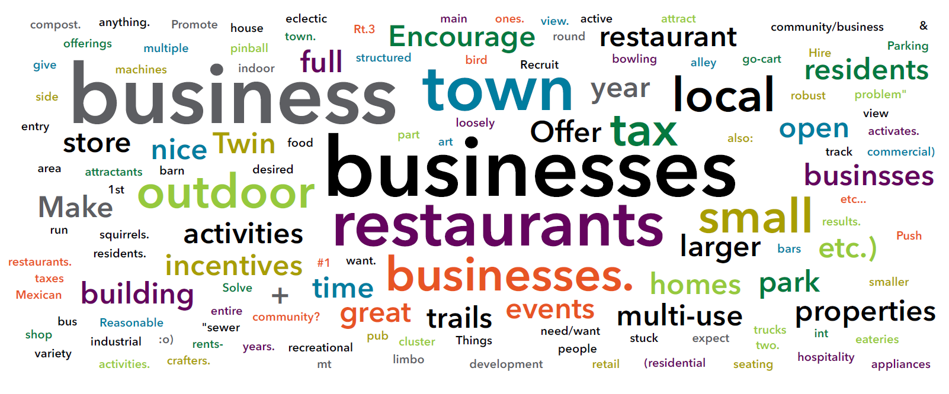

Economic Growth & Development
Due to increasing numbers of visitors from the outdoor recreation-driven economy, Carroll is expected to see economic growth each year. Even if the number of businesses doesn’t increase, there will always be a large portion of customers who spend their money in Carroll, whether residents or visitors.
As shown in Table 1, since 2013, annual employment has slightly decreased, which can also be attributed to the closure of businesses, downsizing at a current employer, and more residents retiring. However, incomes have increased. When you compare 2013 to 2023 there has been a $26,250 increase in median household income. Over the same 10-year period the average weekly wage (private) has increased by $295.

Table 1: Economic Snapshot of Carroll from 2013 to 2023
Years | Labor Force Population (>16) | Median Travel Time to Work | Median Household income | Avg. Annual Employment (Private) | Avg. Weekly Wage (Private)
2023 | 383 | 21.3 | $78,750 | 896 | $854
2018 | 384 | 21.1 | $59,653 | 912 | $655
2013 | 486 | 20.6 | $52,500 | 916 | $559
Source: US Census ACS 5-year Estimates (2009-2013), (2014-2018), and (2019-2023). The last two columns are sourced from NH GRANIT 2023.

Higher incomes for full-time residents contribute to local tax revenue which is reinvested into the community. When dollars are spent locally it also circulates within the community and is reinvested. This positive cycle is referred to as the multiplier effect. The addition of employees to a community helps both small and large businesses. This can also lead to a higher standard of living for residents. With an increase in tourism each year and the rising popularity of working from home, Carroll’s economic future looks bright. Everyone who visits or lives in Carroll would benefit from an increase in businesses, wages, and locally spent dollars.

Working in Carroll
The most common employers located in Carroll fall under a few categories such as:
- Arts, Entertainment, and Recreation, and Accommodations/Food Services
- Retail Trade (Sells merchandise in small quantities)
- Transportation and Warehousing, and Utilities
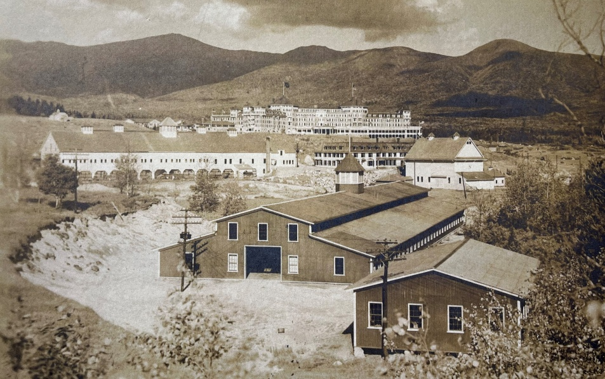
Photo Credit: Twin Mountain-Bretton Woods Historical Society, 2025
Table 2 lists the largest employers located in Carroll. You will notice that most of the descriptions fall under the Arts, Entertainment, and Recreation, and Accommodations/Food Services industry.

Table 2: Largest Employers in Carroll
Employer | Partial Address | Village Area | Description | Employer Size
OMNI HOTEL MT. WASHINGTON RESORT AND RESTAURANTS | MOUNT WASHINGTON HOTEL RD | Bretton Woods | Hotels & Motels, Restaurants | 500 to 999
BRETTON WOODS SKI AREA AND RECREATION SERVICES | SKI AREA RD | Bretton Woods | Skiing Centers & Recreation | 100 to 249
BRETTON WOODS VACATIONS | REMICK LANE | Bretton Woods | Vacation Rentals | 10 to 27
UPS CUSTOMER CTR | LEDOUX DR | Carroll | Shipping Services | 50 to 99
AMC HIGHLAND CTR AT CRAWFORD | ROUTE 302 | Bretton Woods | Hotels & Motels | 20 to 49
STATE POLICE DEPT-TROOP F | ROUTE 302 W | Twin Mountain | State Government-Police | 20 to 49
TWIN MOUNTAIN FIRE DEPT TOWN | 100 SCHOOL STREET | Twin Mountain | Fire Departments | 10 to 19
BRETTON ARMS DINING ROOM | MT WASHINGTON RD | Bretton Woods | Hotels & Motels | 10 to 19
FABYAN'S STATION RESTAURANT | MOUNT WASHINGTON HOTEL RD | Bretton Woods | Restaurants | 10 to 19
BRETTON WOODS STATION | ROUTE 302 E | Twin Mountain | Convenience Stores | 10 to 19
CARROLL POLICE DEPT | ROUTE 3 S | Carroll | Police Departments | 10 to 19
RESORT WASTE SVC | ROUTE 302 | Bretton Woods | Waste Disposal | 5 to 9
IRVING OIL CORP | ROUTE 302 E | Twin Mountain | Service Stations-Gasoline & Oil | 5 to 9
Source: NH GRANIT, 2023 | Largest Employers

Although the majority of Carroll residents don’t work in the Town, when comparing industries that employ Carroll residents there are a few similarities. Arts, Entertainment, and Recreation, and Accommodations/Food Services and Retail Trade are common, as shown in Figure 1.

Figure 1: Carroll Residents’ Industry of Employment, 2010, 2020, and 2022
Source: US Census ACS 5-year Estimates (2006-2010), (2016-2020), and (2018-2022) | DP03
Although there are no educational services, health care, and social assistance employers physically located in Carroll it is the most common employer for Carroll residents. Similarly, the number of residents employed in the Construction industry is high while employers in Carroll are limited. Construction jobs can include carpenters, electricians, roofers, equipment operators, and more.
Most people who are employed in Carroll do not live there. In 2021, 685 employees commuted to Carroll for work (see Figure 2). Only 80 people both work and live in Carroll. The remaining 284 residents live in Carroll and commute to another town for work. These 284 people represent those who are employed in industries not located in Carroll.
Figure 2: Commuting Patterns in Carroll
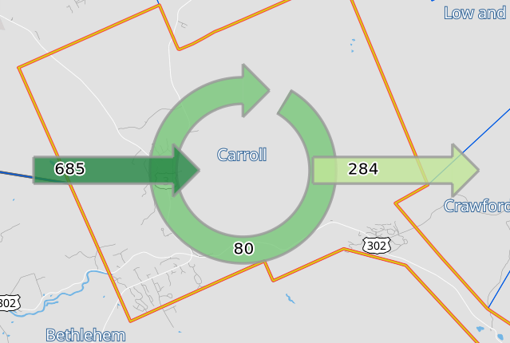

Source: Census OnTheMap 2021

Doing Business in Carroll
Businesses play an important role in a community’s economy and growth. Increasing business helps meet community needs (goods and services), grows job creation and employment opportunities, and promotes entrepreneurship.
As mentioned before, the most popular industry in Town is Arts, Entertainment, and Recreation and Accommodation/Food Services. There’s a multitude of accommodation services in Carroll, ranging from resorts, hotels, motels, cabins and cottages, short-term rentals, and campgrounds. The outdoor recreation-based economy is the number one contributing factor to the high amount of accommodation services.
During the Master Planning community engagement process, residents expressed an interest in focusing on economic development and business growth. When increasing business in Carroll it is important to consider what types of businesses would complement the outdoor recreation and tourism economy in Carroll. Below is a list of complementary businesses to support an outdoor recreation and tourism-based economy:
- Food and beverage establishments
- Outdoor recreation retail stores
- Guided tour companies
- Wellness and relaxation services
- Souvenir and artisan services
- Transportation Services
- Event planning
Residents who responded to the survey said they would like to see an increase in food services like bars and restaurants. This would complement the current economy well while supporting resident preferences.
Strategies for Supporting Economic Development
Permitting Guides help prospective businesses move to town and navigate the process more easily.
A Permitting Guide could include:
- Incentives offered
- Development process (Describes requirements based on the business development process)
- Permit Types and Descriptions
- Parking ordinances and regulations
- Local, regional, state, and federal resources for business development

Economic Development Plans encourage economic growth and improvement. Their goal is to enhance the standard of living, create jobs, and promote economic well-being.

Improving infrastructure and connectivity can make systems like water infrastructure more reliable and allow business to expand operations.
Most retail trade centers are located in village centers that are in close proximity to the accommodation centers and other services. Retail trade stores sell goods or services and can range from grocery to clothing stores and much more. Some residents who responded to the survey said they would like to see an increase in grocery stores and retail businesses.
For current and prospective businesses to grow it is important that Chambers of Commerce support them through advocacy, networking, support for entrepreneurs, economic development initiatives, and promotion. Chambers can provide trainings that help employers and employees thrive. Networking with local businesses builds connections and enhances visibility with cross-promotion opportunities.
A strategy to attract business is to incentivize new businesses. Economic development incentives for local businesses can include tax credits, grants, loans, and infrastructure improvements. Partnering with community banks can provide loans to small businesses. This could be a one-stop, single application portal for local entrepreneurs seeking loans.
Another way to increase business is to promote important services or offerings in the community. A crucial business-friendly offering is cell service. There are currently 6 registered cell towers in the area, which is a relatively low density given the rural and mountainous terrain of the region. However, it does open up possibilities for home-occupations, new start-ups and other entrepreneurial endeavors.

Connecting Carroll

Overview
Carroll is connected through a multitude of services and routes. The town is unique because it contains three state routes including US Route 3 and 302 along with numbered NH Route 115. According to the Carroll Police Department, during peak seasons there could be more than 10,000 tourists visiting and/or traveling through town. Some of the services we’ll discuss in this Chapter include police, waste management, and water infrastructure. These services and more are used by residents each week and connect us. Residents, municipal staff, and various departments have expressed that connectivity – physical and interpersonal – needs to be improved. Connectivity is a good indication of Carroll’s current and future capacity that accommodates both residents and tourists.

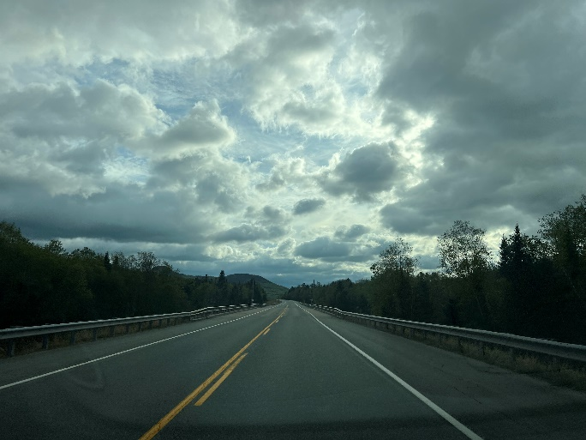
Traffic and Commutes
Photo Credit: Taylor Roy, 2025
There are three primary roadways in Carroll: Numbered NH Route 115, US Route 302 and 3. Each of these routes carries an average of 4,000 vehicles per day (see Table 1 and Map 1). Route 3 north of the Twin Mountain intersection is the most traveled road averaging 6,783 vehicles per day. These counts are conducted on a three-year rotating cycle in the summer season and are approved by the NH Department of Transportation (NHDOT) at the end of each season. In addition to daily and tourist traffic, the three major routes experience heavy tractor-trailer traffic, particularly North Route 3 which is home to multiple shipping/warehousing companies that dispatch trucks from their facilities each day.

Table 1: Daily Average Traffic Counts from 2000, 2010, 2020, and 2023
Location | 2000 | 2010 | 2020 | 2023
US Route 302 East of Rt 3 & 302 Intersection | NR | 3,026 | 4,033 | 4,075
US Rt 3 South of Rt 3 & 302 Intersection | 5,200 | NR | 3,780 | 5,178
US Rt 3 North of Rt 3 & 302 Intersection (Near RR Track Crossing) | NR | 5,300 | 5,869 | 6,783
US Rt 3 North of Rt 3 & 302 Intersection (Between Parker Rd & Ledoux Dr. | NR | NR | 5,446 | 5,498
NH Rt 115 | NR | NR | 2,753 | 4,291
Lennon Road | 120 | NR | 137 | 186
US Rt 302 East of Rt 3 & 302 Intersection (over Ammonoosuc River) by Base Station Road Intersection | NR | 2,700 | 3,600 | 3,842
Base Station Road | 1,400 | NR | 632 | 1,793
Mt Clinton Road | NR | NR | 114 | 102
Source: NHDOT Traffic Count TDCS, https://nhdot.public.ms2soft.com/tcds/tsearch.asp?loc=Nhdot&mod=TCDS, NR= No Record
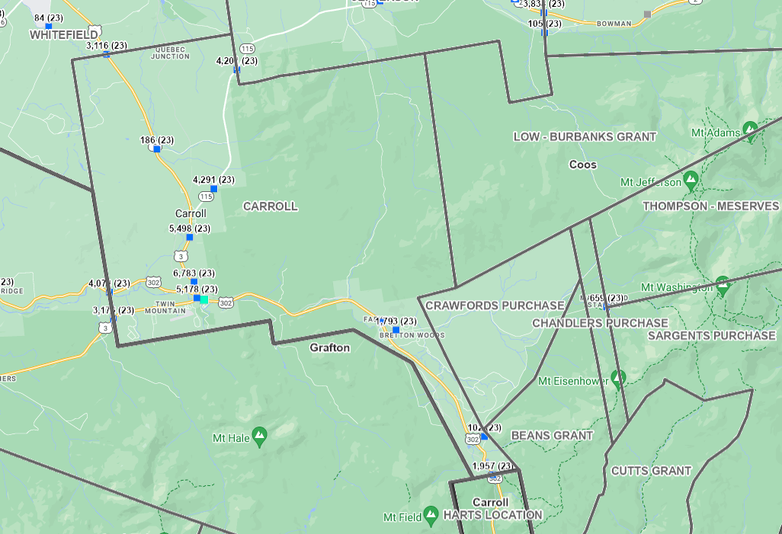
Map 1: Daily Average Traffic Count Map
Source: NHDOT Traffic Count TDCS, https://nhdot.public.ms2soft.com/tcds/tsearch.asp?loc=Nhdot&mod=TCDS
As shown in Figure 1, over 90% of households in Carroll have at least one vehicle, with the majority (42%) being 2-car households. With most households driving and with increasing amounts of traffic along Carroll’s main roadways, it’s not surprising that residents have expressed that traffic is the 5th most important municipal issue in the Master Plan Survey. Residents stated that they would like to see traffic speeds reduced near Town Center areas and along Main Street.
Figure 1: Vehicles Per Household in Carroll, 2021
Changing roadway patterns, speeds and features can make roadways safer – so can adding or expanding pedestrian routes/bike routes. Pedestrian routes/bike routes are interior or exterior ways of passage for pedestrian travel like sidewalks, stairs, and ramps or bicycles. These routes not only focus on pedestrian features / bike features but the overall connected network. Pedestrian routes/bike routes help prevent accidents and create more walkable/bikeable communities.
Safer Roads with Sharrows
To reduce speeds and make village areas safer for all, including pedestrians, Carroll should consider adopting traffic calming strategies. For example, sharrows are road markings consisting of two chevrons (arrows) that indicate a shared lane for cyclists and motorists. They promote safer co-existence between vehicles and cyclists on shared roads.
NHTSA Traffic Safety Countermeasures That Work in Rural Communities
Lastly, maintaining and improving road conditions is critical for user safety. Proper conditions help prevent accidents and are easier on vehicles. Maintenance measures include addition of signage, striping and restriping as needed, adding and maintaining streetlights, and adding delineators.

Municipal Buildings and Services
Residents are connected through municipal buildings/locations and services provided by the Town. These buildings and services are essential for the safety and well-being of residents. Table 3 is an inventory of the locations and buildings that provide services owned by the Town of Carroll.
Table 3: Municipal Buildings and Locations
Building Name | Address | Visual Reference
Town Hall/Offices/Library | 92 School Street | 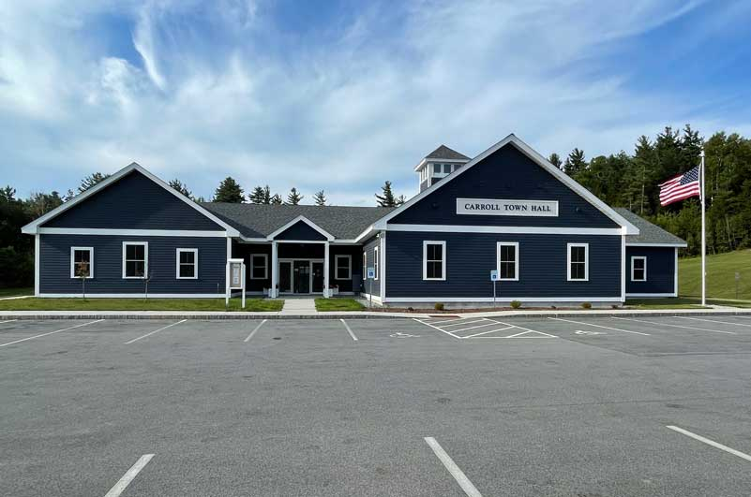
Fire Department | 100 School Street | 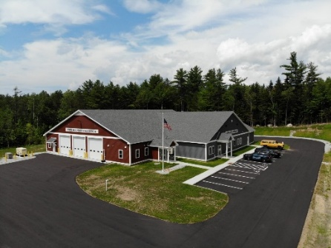
Police Department | 102 School Street | 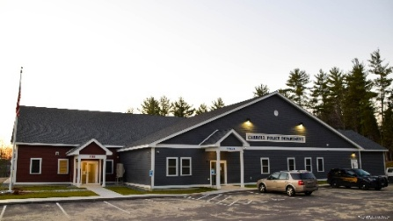
Recycling Center and Transfer Station | 240 New Straw Road | 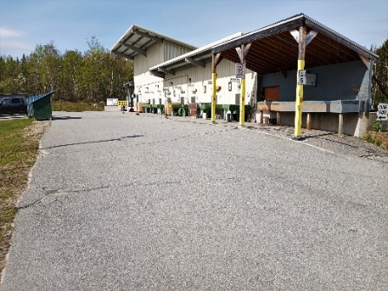
Public Works Building | 305 Parker Road | No image available
Recreation Area | 178 Lake Rd | 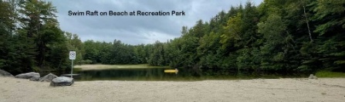
Rosebrook Cemetery | Rt. 302 West | 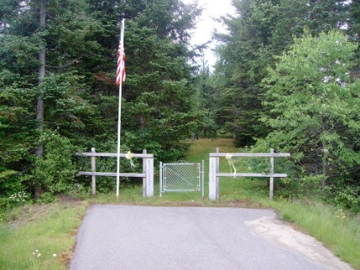
Straw Cemetery | Rt. 3 North | 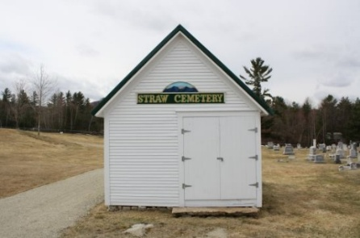
Crawford Cemetery | Stickney Circle | 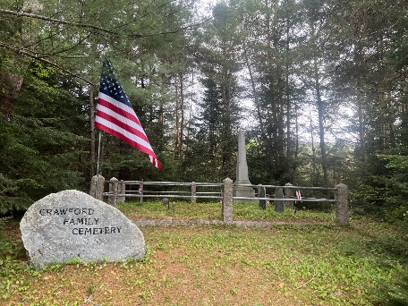
Source: Town of Carroll, 2024
It is important to take an inventory of the frequency and amount of services used to determine the capacity of the current system. Table 4 summarizes the municipal services provided by the Town of Carroll in 2024.

Table 4: Municipal Service Calls by Department, 2024
Department | Number of Calls/Citations | Type of Calls
Police | 8,277 Calls | Not listed
Police | 990 Citations | Not listed
Fire | 113 Calls | Not listed
Ambulance/EMS | 220 Total Calls
Ambulance/EMS | 81 | Non-Transports
Ambulance/EMS | 57 | Medical
Ambulance/EMS | 47 | Transports from Bretton Woods Ski Area
Ambulance/EMS | 27 | Traumatic Injuries (not at Bretton Woods)
Source: Town of Carroll, 2024 Town Report
For communities to thrive, it is also important to have volunteer efforts aligned and in regular communication. Effective communication between Town groups, boards, and committees is crucial to fostering trust and collaboration. Enhanced communication can facilitate effective event planning and streamline the distribution of community resources to both residents and visitors. An increase in resources and events can make a Town a more attractive and welcoming place.

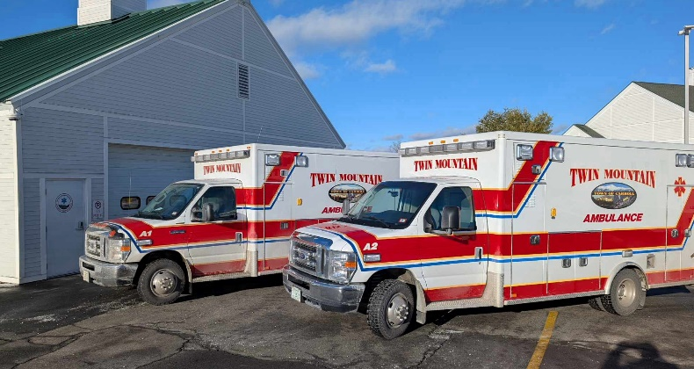
Infrastructure
Photo Credit: Town of Carroll, 2025
Water infrastructure plays a key part in increasing and attracting businesses and dwellings in Carroll. There are currently 437 accounts using Town water. Carroll’s Public Works Department is in the process of understanding how to increase water capacity to accommodate the growing population and businesses. The water main consists of 6-to 8 inch water mains throughout Town. Modern standards suggest that at least 8-inch water mains are preferred. In 2024, there were two (2) water-main breaks and two (2) service line breaks. Overall, the system pumped close to 52,000,000 gallons in 2024.
Carroll’s water system is concentrated along major routes in the Town (as shown on Map 2). It would be ideal to continue developing residential and commercial/industrial growth along the main corridors to reduce the cost of expanding the lines, especially in sensitive areas such as wetlands and along steep slopes.
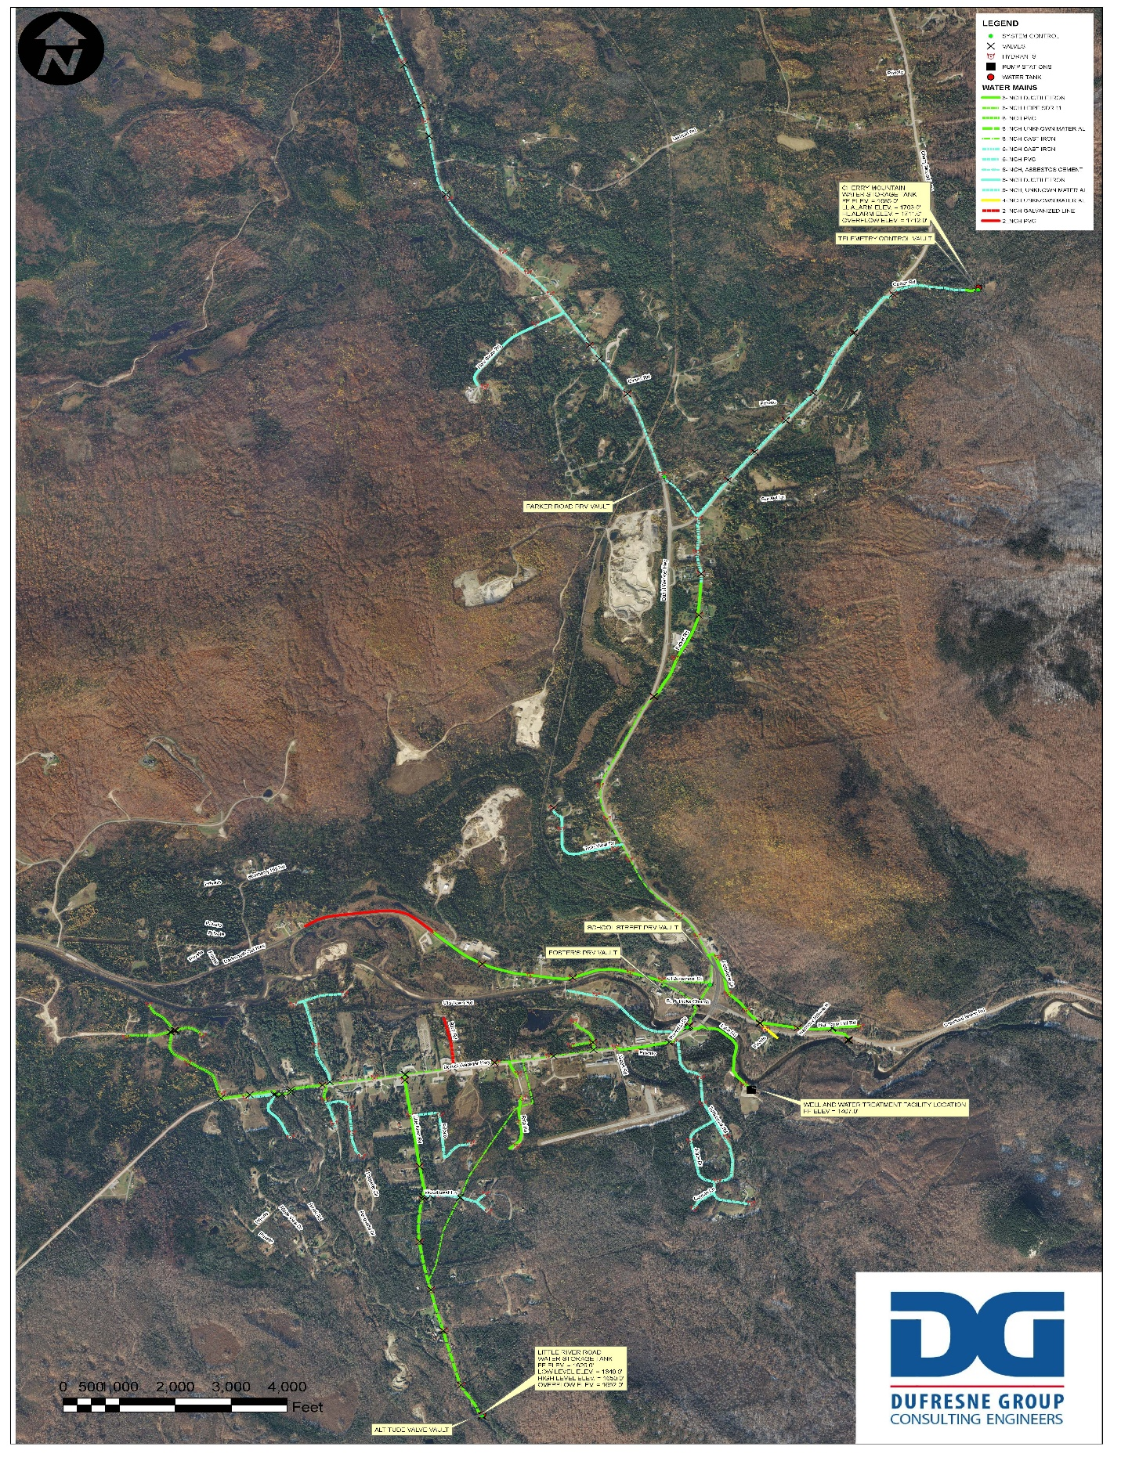
Map 2: Carroll’s Water Infrastructure, 2018
Source: Dufresne Group Consulting Engineers – former engineering firm for the Town of Carroll
Over time, land development can impact the quality of stormwater runoff. Typically, stormwater filters through vegetation and soil before reaching the groundwater. However, as land is developed, impervious surfaces prohibit infiltration, which drains untreated water into rivers, lakes, and streams, some of which are drinking water sources. It is important to consider the location of new developments and employ effective mitigation strategies to reduce or eliminate impacts on water resources.
Protecting Water Quality
Water and wastewater reduction strategies can include:
- Smart water meter: real-time proactive management
- Leak detection systems: reducing non-revenue water loses
- Greywater recycling: maximizes water reuse (takes “shower” water and reuses it in the toilet)

Increased development should be managed so that municipal infrastructure and resources are available for all residents. This can be achieved by creating a Municipal Development Plan. This Plan forecasts projects over a 5-year period and can be used to plan for land use, development, and resource conservation. This plan can help the Town plan for infrastructure upgrades, pavement management, staffing, and other essential programs that help the municipality run smoothly.

It should be noted that Bretton Woods is served by a separate water and sewer systems. The water system is managed by a professional public utility, with ongoing investment in infrastructure and transparent reporting. Wastewater is handled by a local nonprofit, ensuring community oversight and adherence to environmental standards. Although they are not included in a 5-year Municipal Development Plan, it is important to note these two systems that are separate from the rest of the Town.

Energy
Increasing energy efficiency is a great way to provide the same or greater amount of resources with less energy. This could include switching to renewable energy sources, such as solar, geothermal, and wind. A great way for municipalities to promote renewable energy is to lead by example. The Town has actively pursued clean energy solutions for its municipal buildings, including the Town Hall, Police Station, and Fire Department. The Carroll Energy Commission, established by the Select Board in October 2023, has been leading these efforts, with a mission to advise and facilitate energy conservation and clean energy projects for public buildings. In 2025 the Town will complete their first solar installation on the Town of Carroll Municipal Complex. These arrays will help supply energy to the municipal complexes and lower energy costs over time. The total cost for the solar panels is $151,766. The Town will use $143,766 from the Town’s new Land and Building Capital Reserve Fund and $8,000 from the Town Energy Efficiency Capital reserve fund and replace the funds when we get the grant money. Grant funds will come from:
- U.S. Department of Energy, Energy Efficiency and Conservation Block Grant, Municipal Solar Grant Program: $86,236
- An IRA Elective Pay investment tax credit: $45,530
- NH Department of Energy Commercial and Industrial Solar Incentive for $10,000
Another strategy for increasing energy efficiency could be to install public and private electric vehicle (EV) charging stations. Popular locations in town, like Bretton Woods or other tourist destinations, could consider installing EV charging stations to accommodate an increase in electric vehicle use. The 2022 EY Mobility Consumer Index found that “52% of car buyers are considering an EV for their next purchase.”

Tourism
Increasing Revenue from Tourism
There are a couple of ways a municipality could increase the revenue they receive from tourism:
- Increase business which would amplify the amount of funds spent in town
- Increase full-time residents to receive more funding
- Propose a change to the meal and room tax legislation to give more money to municipalities.

Tourists play a big role in Carroll’s economy and largely depend on municipal services such as EMS, police, water, fire, recreation areas, and roads. A percentage of the money tourists spend on Accommodations and Dining in Carroll is allocated back to the Town in the form of a Room and Meals Tax. Towns receive 40% of the Room and Meals tax revenue based on their population. As shown in Table 5, $82,171.58 represents 40% of the total Room and Meals Tax revenue projected for the Town of Carroll in 2025. This comes to less than $100 per resident. The other 60% ($123,257.37) is allocated to the State of New Hampshire. Often, Towns with high tourism and low populations feel disadvantaged by the amount of money they are allocated each year.
Table 5: Rooms and Meal Tax Revenue per Resident, 2023-2025
Year | Meal Tax Revenue | # of Residents
2023 | $72,406.26 | 831
2024 | $78,719.00 | 839
2025 | $82,171.58 | 843
Source: Town of Carroll, 2024 Town Report

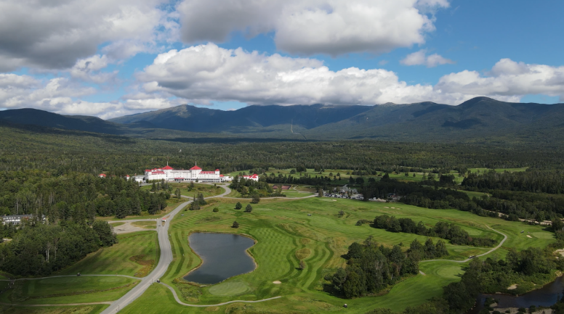
NH Business and Economic Assistance (NH BEA) 2023 NH Outdoor Industry Inventory (NH-ORID-Outdoor-Industry-Inventory-Report_2024-compressed.pdf) found that “Out-of-State visitors spend an average of $115 per day during their visit, with an average stay of 2.75 days.” The nearby outdoor recreation amenities are linked to the major source of tourism in Carroll. The White Mountain National Forest accounts for more than 50% of the land area in Carroll, receiving around 4.4 million visitors annually. Among those visitors 85% of them went for recreation purposes. Additionally, a little over half of the visits come from people who live within 50 miles and one-fifth of the visits come from people who live more than 200 miles away. It is important to consider the municipal capacity of services for residents and visitors who use Carroll’s services.

Tips for Supporting Municipal Connections
The following tips summarize three primary initiatives the Town can engage in to create, enhance and support natural, man-made and human connections:
- Develop a comprehensive public facilities inventory that plans for upgrades and maintenance of essential systems over a 5–10-year period. As Carroll continues to grow, this plan can be used to ensure there enough resources in town to handle the higher population and additional businesses.
- Increase communication between town committees, groups, departments, and stakeholders. Projects, events and initiatives throughout Town should be discussed by multiple parties who hold an interest or a stake. Different groups and stakeholders can bring multiple perspectives to a discussion and make the project, initiative, or improvement a greater success.
- Hire a Town Planner to handle the future influx of development and infrastructure. They are responsible for helping manage development and review existing areas for potential impacts, communicate across departments, mange the development of a Capital Improvements Plan or Public Facilities Inventory (as mentioned above), apply for grant funding, communicate with the public and a host of other essential tasks to improve and support connections in a community.

Photo Credit: Town of Carroll, 2025

Designing Our Community

Overview
A community is characterized by its land use and how they are laid out, the aesthetics of its buildings, parks, housing developments and businesses and also by the social structures that uphold it, including community programs and volunteer efforts. Building on public input at the Community Meeting in the fall of 2024, the community survey, and feedback from Town staff and volunteers, this Chapter analyzes existing land use, Town character and the Town’s assets to prepare the Town for guiding future development, enhancing the sense of community, and ensuring that growth is both sustainable and reflective of local priorities. By integrating thoughtful planning with respect for the Town’s natural beauty and heritage, this chapter can be a roadmap for creating a vibrant, connected, and resilient community.

Photo Credit: Paula Murphy, 2025

Land Use in Carroll
The Town of Carroll has a mix of residential, commercial, industrial, rural, and significant conservation lands. The Town is divided into five primary zoning districts, each with distinct permitted uses and development standards:
Table 1: Zoning Districts & Primary Uses
RES 1: Residential 1 | Single-family and two-family dwellings, some multi-family (by special exception), home businesses, and select institutional uses. Minimum lot size: 1 acre.
RES 2: Residential 2 | Similar to RES 1, but with some expanded uses for multi-family and institutional buildings. Minimum lot size: 1 acre.
R-B: Residential-Business | Mix of residential, commercial, and some light business uses. Located primarily along US Route 3 and US Route 302. Minimum lot size: 1 acre.
IND: Industrial | Intended for industrial and certain commercial uses, such as contractor yards, warehouses, and wholesale businesses.
RU: Rural | Primarily for agriculture, forestry, conservation, and low-density residential uses. Also includes municipal recreation and utility uses.
Wetlands Overlay District | Provides additional protection and regulation for wetlands and their surrounding areas within the Town.
Aquifer Protection Overlay District | Protects, preserves, and maintains groundwater supplies and recharge areas within identified aquifers.
Village Overlay District | Overlayed on the existing RES 2 District to provide additional land use regulations and standards specific to that area.
Airport Overlay District | Addresses issues specific to the airport area, such as safety and compatible land use, in order to protect airport operations and public safety

Each district has specific requirements for lot size, frontage, setbacks, and building heights, designed to maintain the character and function of each area.

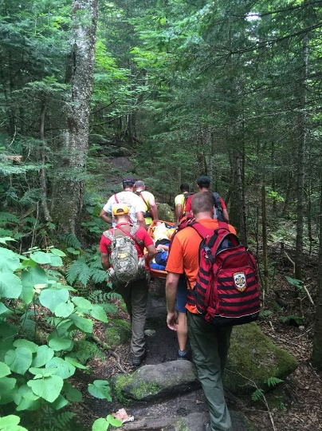
Beginning with the largest land use in Town, over half of Carroll’s total acreage is conservation land and undeveloped, thanks to past and ongoing efforts by local and regional organizations to secure conservation easements and protect high-priority resource lands, especially in areas with valuable wildlife habitat and water resources. In addition, many landowners with large tracts have opted for current use status, helping maintain the town’s rural and undeveloped character. These conservation lands play a critical role in shaping land use and future development and include:
Photo Credit: Town of Carroll, 2025
- White Mountain National Forest: Federal land with strict development limitations.
- Pondicherry/Silvio Conte National Fish and Wildlife Refuge: Protected area for wildlife habitat and water resource conservation, through a partnership between US Fish and Wildlife Service, NH Fish and Game Department and NH Audubon. This extensive property is located in Carroll, Jefferson and Whitefield.
- Livingston Conservation Easement (“The Flats”): Privately-owned land under permanent conservation easement.
- Town Recreation Area: Municipal land used for recreational activities and events.
- NH Fish & Game Hatchery: State-owned lands for resource management.
- Current Use Lands: Approximately 9,991 acres, or 31% of the Town, are enrolled in New Hampshire’s Current Use program, primarily as forest, farm, or unproductive land, which encourages conservation by offering tax incentives for keeping land undeveloped.

Table 2: Current Use Acreage for Carroll
 | Total Land Acres | Total Current Use Acres | Total Conservation Acres | Federal
 | 32,171.41 | 9,996.66 | 17,589.24 | 16,714 +/-
Source: https://data.census.gov/profile/Carroll_town,_Coos_County,_New_Hampshire?g=060XX00US3300710100, https://data.census.gov/profile/Coos_County,_New_Hampshire?g=050XX00US33007, https://www.nhhfa.org/, Image Google Earth, Dept Revenue 2022 Current Use Report and NH OPD
Developed land of Carroll is located in one of two main villages in the Town: Twin Mountain, which is where most of the commercial uses are located, occupying the southern part of town along Routes 3 and 302. And Bretton Woods, which is located in the eastern part of Carroll, is surrounded by the National Forest, and well known for the ski resort and other recreational uses as well as the Mt. Washington Hotel. Bretton Woods also includes 419 residential units, consisting of houses and condos in thirteen Homeowners Associations. To support these uses (commercial and residential), Bretton Woods operates its only water and wastewater treatment, a transfer station, and their roadways.

Future Land Use
To date, Carroll’s land use framework has been designed to promote orderly growth in designated residential, business, and industrial areas; Preserve large tracts of forest, farm, and conservation land; protect critical natural resources and wildlife corridors; and maintain the rural, scenic character valued by residents.
When asked about future growth in the community, residents expressed a desire to see:
- Business growth and expansion
- Residential growth (with a focus on single-family, cluster, older adult and small starter housing types)
- Indoor and outdoor recreational activities
- Enhancement of the Town Center at the junction of Route 3 and Route 302
- Preserving open space

In addition to the specific strategies in the Implementation Chapter, Carroll can support these land uses by:
- Keeping growth along corridors and in areas that are currently developed
- Limiting large developments
- Redeveloping existing parcels
- Considering zoning updates to allow for mixed use along corridors
- Maintaining storm drains
- Collaborating with developers who build desired housing types

Map 1: Land Cover in Carroll
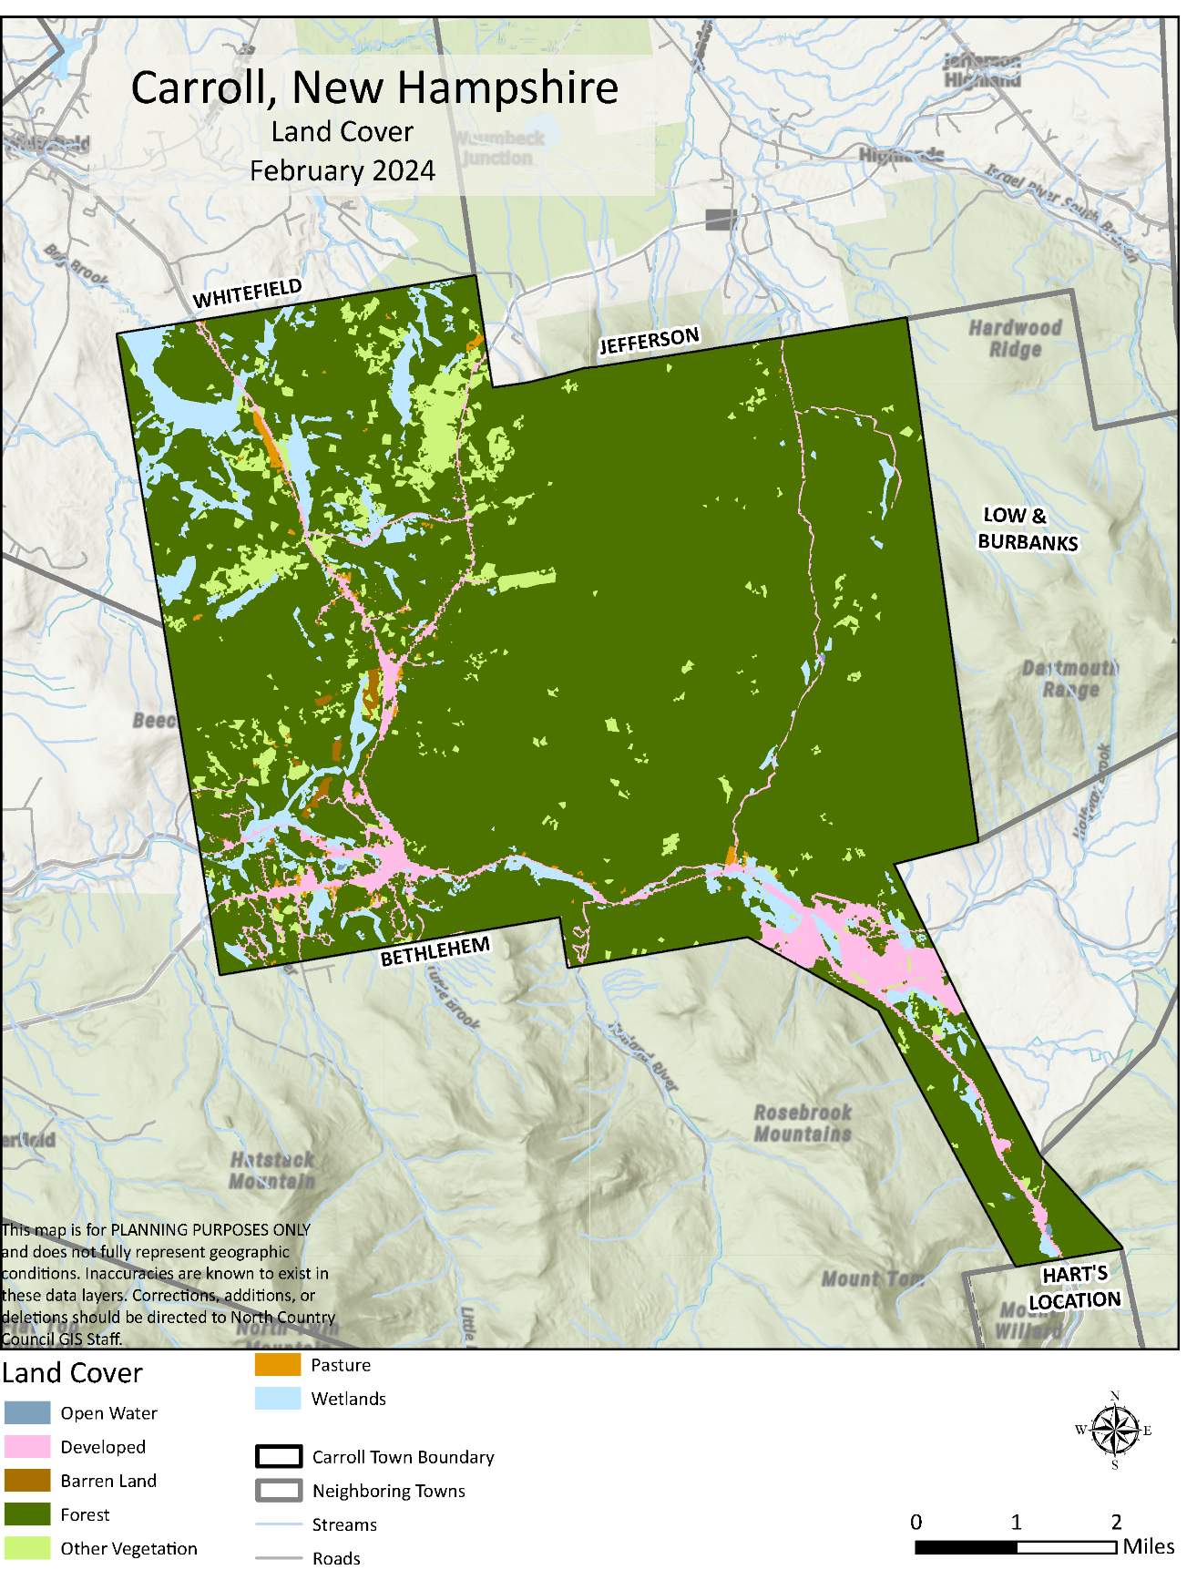

Town Character
The Town of Carroll is made up of four loosely defined villages: Twin Mountain, Bretton Woods, Fabyan, and Crawfords, each with its own character and features. The Town Center is in Twin Mountain and functions as the main crossroads and community focal point. There, you’ll find historic sites, community facilities, lodging, and local businesses. The town’s layout reflects its history as a crossroads for tourism and outdoor recreation in the White Mountains, rather than a single, centralized village. The Town Center is at the junction of Route 3 and Route 302 and currently includes:
- The stone St. Patrick Church, a notable landmark
- The Boulder Motor Court Cottages, a cluster of attractive tiny houses
- A grassy hillside featuring a historic Cog Railway engine and the Twin Mountain tourist information gazebo, which marks the site of the former Twin Mountain House grand hotel
- The Town Hall, Library, and Public Safety Complex. In addition to traditional Town services, these facilities are used for public gatherings, historical displays, barbecues, music, and other celebrations
- Several local businesses, eateries and convenience stores

When surveyed, residents said that the best ways to enhance community character would be to
Abandoned Properties
While it’s a challenge to have abandoned and run-down buildings in our community, we need to consider that landowners face obstacles to addressing them. Some of the reasons owners leave buildings dilapidated or abandoned include:
- Cost
- Logistics (time or health constraints)
- Emotional attachment
- No available buyers

- Create a more visible, distinct Town Center that is walkable and has retail components
- Improve post-office
- Increase agriculture/greenery/flowers
- Increase walkability of Main Street and between businesses
- Crosswalks in Route 3 and Route 302 intersection
- Bandstand improvements
- Address dilapidated and abandoned buildings

There are a number of solutions to abandoned or dilapidated buildings, which can be used in concert with each other.
- Adaptive reuse: repurpose buildings for new uses
- Rehabilitation: repair, renovate, or improvement of the building so it’s habitable
- Code Enforcement; Property Maintenance Code: laws that list property standards that shouldn’t be violated. It also manages vacant lots
- Community Cleanups: this brings community members together to clean up a building or lot. Permission of property owner(s) is needed for this.
- Condemning: legal process where property is declared unfit for use or rehabilitation due to safety, health, or structural concerns
- Neighborhood purchase: property or building is purchased by residents. It can be used as community property or cleaned up and sold on the market

Town Services and Programs
Carroll provides a range of essential services and community programs designed to meet the needs of residents and support a safe, healthy, and vibrant community.
- Town Clerk: The Town Clerk’s office manages vital records, licenses, and permits, and serves as a central point for town information. Office hours are available throughout the week.
- Code Enforcement: The Code Enforcement Office ensures community safety and compliance by overseeing building permits for new construction, additions, and certain structures like decks, barns, and garages. Residents are encouraged to contact the office for guidance on permit requirements and inspections.
- Highway Department: Responsible for the maintenance of town roads and infrastructure, the Highway Department addresses road repairs, snow removal, and related public works. The Highway Department also manages the Town’s Transfer Station. Residents can contact the department directly with concerns or to schedule appointments.
- Water Department: The Water Department manages the public water supply, including billing, maintenance, and emergency response. Assistance programs are available for residents struggling to pay water bills, including access to state-funded support for overdue payments.
- Library: The Twin Mountain Public Library is located at 92 School Street. The library offers a wide selection of books, including popular fiction, classics, and a vibrant Children's Department with a dedicated reading room. The library provides free computer use and internet access, as well as wireless internet for visitors during its operating hours. An online catalog is also available for users to browse and discover new reading materials by author or genre.

Community Programs and Events in Carroll
The Town offers a vibrant array of community programs and events, many of which are run by dedicated volunteers. These programs and events include:
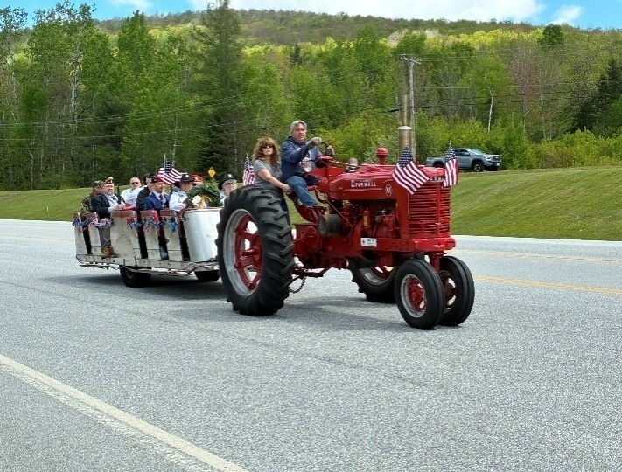
- The Bretton Woods Ski Program introduces local children to skiing and snowboarding.
Photo Credit: Austin Alvarez, 2025
- An annual Kid’s Fishing Derby, bringing together residents for a fun and friendly competition.
- Memorial Day Parade and BBQ
- A popular Fourth of July fireworks display, enjoyed by the entire community.
- Sip ‘N Paint events, which have become a well-attended and requested social activity for adults.
- Cribbage Tournaments
- Garden Club
- Pancake breakfasts
- Book Club
- Historical Society

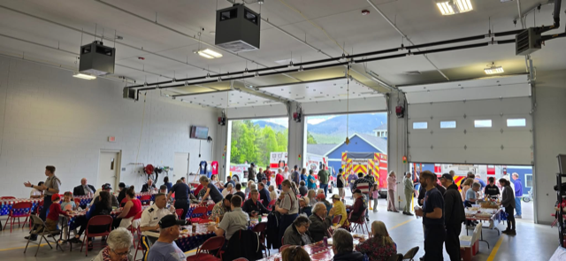
Carroll’s recreation facility, located at the end of Lake Road, is open daily from 8am until dusk. These amenities provide residents and visitors with year-round opportunities for outdoor fun and exercise. It features:
Photo Credit: Town of Carroll, 2025
- A playground
- Ball field
- Basketball court
- Swimming area

Carroll is known for its four-season recreational opportunities. The Town’s natural setting between Franconia Notch and Crawford Notch makes it a hub for outdoor adventure and community gatherings throughout the year. Residents and visitors can enjoy:
- Cross-country and downhill skiing
- Snowmobiling
- All-season hiking and biking
- Swimming holes in summer
- Bird and moose watching
- Golfing

Carroll residents and visitors also have access to a rich array of arts and cultural opportunities. Bethlehem is home to the Colonial Theatre, one of the oldest continuously running theaters in the U.S., featuring movies, live shows, and cultural events from May to October. The Weathervane Theatre in Whitefield is celebrating 6 decades in the White Mountains, bringing Broadway to the North Country. The Weathervane is an award-winning theatre that offers mainstage productions, a theatre series for young audiences and special events. The North Country Chamber Players bring internationally recognized classical music performances to the region during summer, including concerts at the Omni Mount Washington Resort in Bretton Woods. The area is also home to several art galleries, such as the Carroll Studio Gallery, which showcases works by the Carroll family artists in various media. History and heritage are celebrated through local museums like the Littleton Historical Museum, Franconia Heritage Museum and the White Mountain Museum, while the scenic White Mountain National Forest and historic sites like the Mount Washington Cog Railway add cultural depth to the visitor experience.
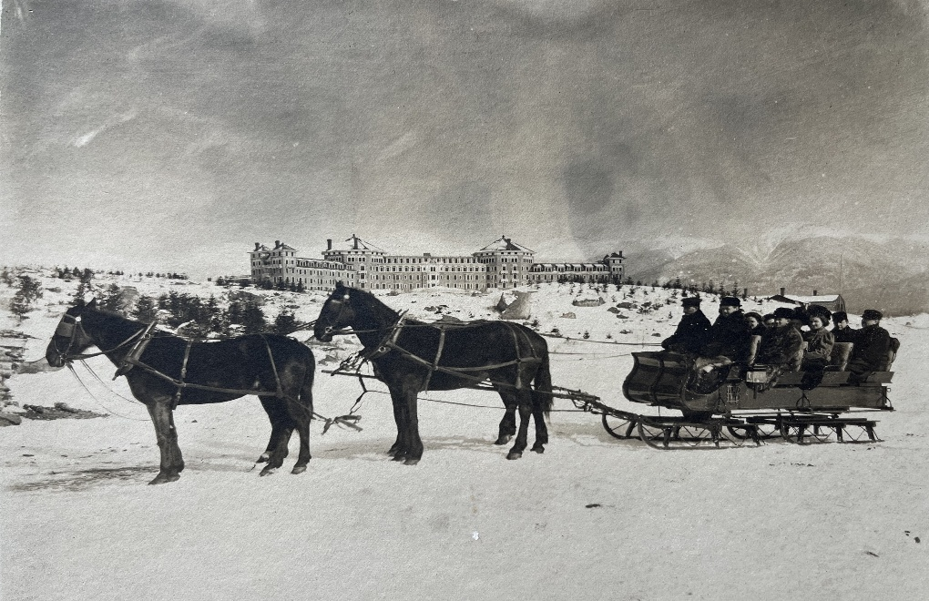
Promoting and offering diverse programs and venues enriches the lives and experiences of residents and visitors to Carroll. It is essential to design a community that is livable and sustainable.
Photo Credit: Twin Mountain-Bretton Woods Historical Society, 2025

Environmental Stewardship

Introduction to Carroll’s Environment
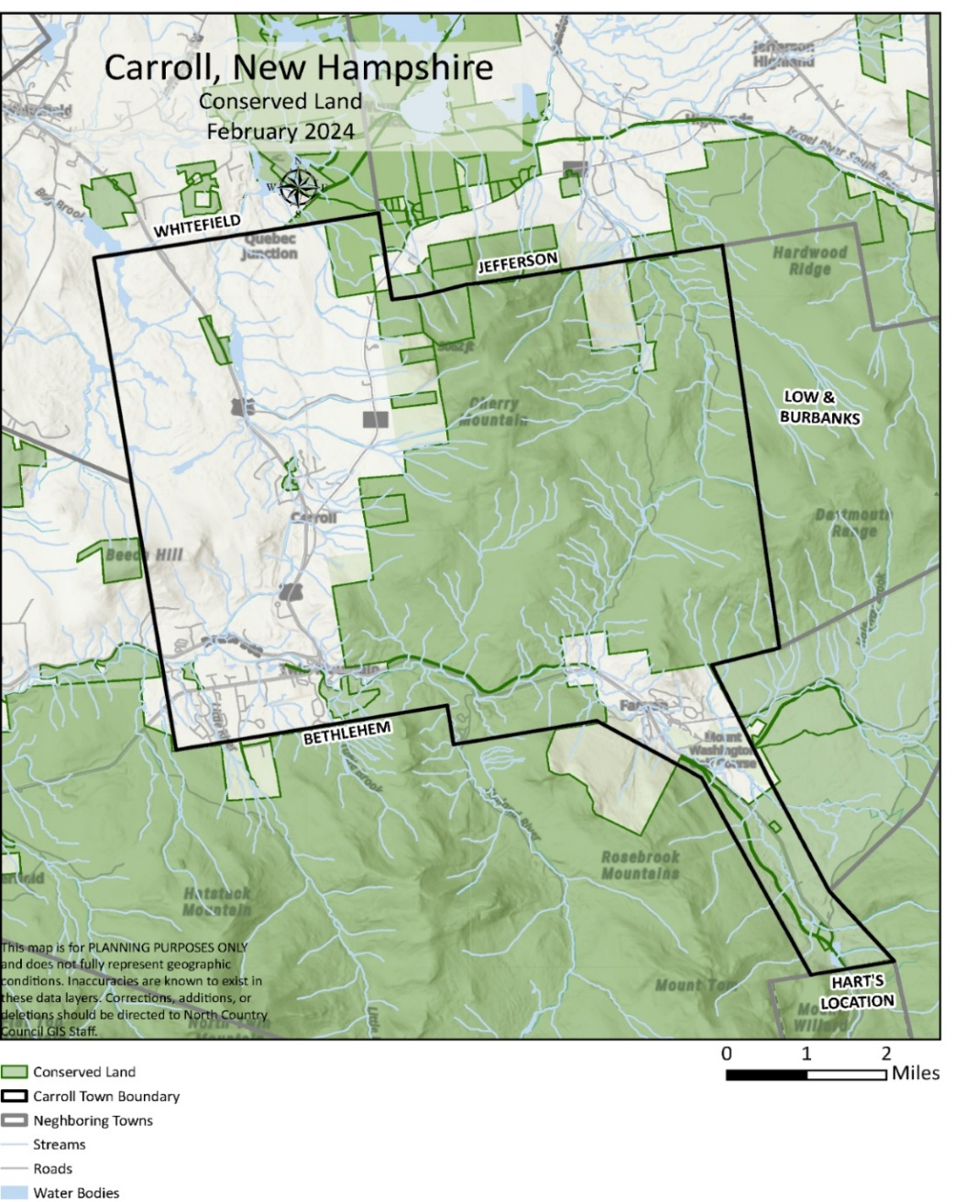
Carroll is defined by its remarkable natural landscapes, from the vast stretches of the White Mountain National Forest to the pristine waters of the Ammonoosuc River and vital wildlife habitats that enrich the community’s character and quality of life. The Town has unique responsibility to protect these invaluable resources for current and future generations. As shown in Map 1, over half of Carroll’s 32,000 acres are designated as conservation land, including national forests, wildlife refuges, and locally protected areas. The Town’s continued stewardship efforts are critical to maintaining clean water, healthy forests, diverse habitats, and scenic beauty. This chapter provides an overview of Carroll’s outdoor recreation, natural environment, important species and the climate conditions that impact both our human and natural ecosystems. With this information, the Town can sustain Carroll’s environmental assets, balancing thoughtful development with the preservation of the natural systems that support the Town’s ecological health, recreational opportunities, and rural identity.
Map 1: Conservation Land in Carroll

Outdoor Recreation
Recreational Opportunities in Carroll, NH
- Hiking
- Swimming
- Snowmobiling
- Skiing
- Fishing
- Golfing
- Mountain biking
- Camping
- Hunting
- Wildlife Viewing
- River sports (Rafting and Kayaking)

Carroll is renowned for its wealth of outdoor recreation opportunities, which attracts residents and visitors year-round to enjoy the scenic landscapes and diverse activities. Recreational opportunities are available on town-owned properties, privately held land in current use, land owned by non-profit organizations and federal land in the White Mountain National Forest. The Town is committed to continuing to expand offerings and is working to create new opportunities that are accessible, safe, and ensure that people of all ages and abilities can explore and benefit from the outdoors.
Three of the most popular outdoor activities in the North Country are hiking, snowmobiling and skiing, and Carroll offers them all! Carroll’s trail system is designed for versatility, supporting activities such as hiking, snowshoeing, cross-country skiing, snowmobiling, and nature study. Multi-use trails provide year-round recreation and are planned to minimize environmental impact, avoiding sensitive habitats and steep slopes to protect local wildlife and reduce maintenance needs. These trails foster community by connecting neighborhoods, parks, and natural areas, and by providing opportunities for people to recreate together, regardless of their preferred activity.
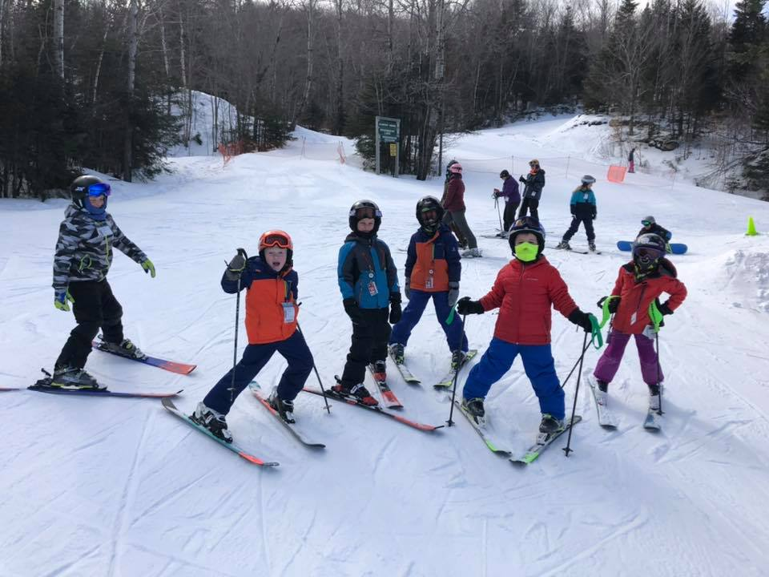
According to data from NH GRANIT (Table 1), there are approximately 152 trails in Carroll, with hiking trails topping the list at 74. These are trails that are primarily on public land that were officially mapped and included in this statewide database. Organizations and agencies like the Appalachian Mountain Club, Ammonoosuc Conservation Trust, and Twin Mountain Snowmobile Club have more information on trails that may not be included in the state’s database.
Photo Credit: Town of Carroll, 2025
Table 1: Recreational Trails in Carroll
Trail Types | Number of Trails
Pedestrian | 74
Snowmobile | 46
Alpine Skiing | 32/102*
Nordic Skiing | 56
Total Trails | 208
Source: NH GRANIT, 2022. https://nh-granit-nhgranit.hub.arcgis.com/
and https://www.omnihotels.com/hotels/bretton-woods-mount-washington/skiing/nordic/nordic-trail-report (for Nordic Skiing)
*70 of the trails are located in the Town of Bethlehem, but these trails are accessed through Carroll at Bretton Woods Resort (https://www.skinh.com)

Carroll and the broader northern New Hampshire region offer several handicapped-accessible trails, making nature accessible to everyone, including those with mobility challenges. Local adaptive sports programs, such as those at Bretton Woods and nearby ski areas, provide specialized equipment and instruction so individuals with physical or cognitive disabilities can participate fully in activities like skiing, snowshoeing, and hiking. These efforts are supported by dedicated staff and volunteers from organizations like the Adaptive Sports Partners (located in the neighboring town of Franconia), ensuring a welcoming and boundary-free environment for all.

Weather and Climate

Over the past 25 years, 33 disasters have been declared in Coos County, most of which were related to severe storm incidents. As shown in Table 2, over the past 10 years both accumulation (rain, snow, hail, sleet, etc.) and mean maximum temperatures have risen. When you compare 2014 to 2024, the average temperature has risen by 2.4 degrees Fahrenheit, and accumulation has risen by 6.95 inches in the last 10 years. According to some climate predictions, the average summer temperature is expected to rise by 2.4 degrees Fahrenheit by 2100. The lowest recorded accumulation year in the past 10 years was 2020 followed by 2021. Publications cited that the cause of the low accumulation in these two years was summer droughts, and not from a lack of snowfall. The highest mean temps were recorded in 2016, 2024, and 2020.
Photo Credit: Town of Caroll, 2025
Table 2: Temperature and Rainfall in Coos County, 2014-2024
Year | Mean Max Temperature (F) | Accumulation (in)
2014 | 53.7 | 35.43
2015 | 54.9 | 37.2
2016 | 56.4 | 35.59
2017 | 55.4 | 38.61
2018 | 54.5 | 36.15
2019 | 53.0 | 38.12
2020 | 56.0 | 25.4
2021 | 55.4 | 27.1
2022 | 55.8 | 34.61
2023 | 55.2 | 39.65
2024 | 56.1 | 42.38
Source: https://www.augurisk.com/risk/state/new-hampshire/carroll/33003
According to the Carroll Hazard Mitigation Plan of 2024, 11 natural hazards could impact Carroll. The following hazards are in order of their probability of impacting the Town:
- High Wind Events (High Risk)
- Inland Flooding (High Risk)
- Extreme Temperatures (High Risk)
- Lightning (Medium Risk)
- Several Winter Weather (Medium Risk)
- Infectious Disease (Medium Risk)
- Landslide (Medium)
- Drought (Low)
- Tropical Storm (Low)
- Earthquake (Low)
- Wildfires (Low)

Any potential disaster in Carroll is particularly impactful if combined with a long-term utility outage, as would most likely be true with severe winter storms, blizzards, ice storms, hurricanes, tropical storms, and windstorms. An outage could result in frozen pipes and a lack of water and heat during the winter, a concern for the Town's vulnerable citizens, including older adults and people with mobility and/or health issues. The food supply of individual citizens could become quickly depleted should a power failure last for a week or more. When combined with a long-term utility outage, a hazard could have a higher probability of damaging impacts on the community.
Table 3 outlines the flooding events in the North Country between the year 2000 and 2023. In Carroll, those events have primarily involved flash flooding. As shown in Map 2, flood zones are along Route 302, which parallels the Ammonoosuc River.
Table 3: Flooding Events in the North Country, 2000-2023
Type | Location | Date
Flood | Southern Coos (Zone) | 4/6/2000
Flood | Southern Coos (Zone) | 5/11/2000
Flood | Southern Coos (Zone) | 4/23/2001
Flood | Southern Coos (Zone) | 4/14/2002
Flash Flooding | Coos County | 6/12/2002
Flood | Southern Coos (Zone) | 3/30/2003
Flood | Southern Coos (Zone) | 4/3/2005
Flood | Southern Coos (Zone) | 4/24/2005
Flood | Southern Coos (Zone) | 10/15/2005
Flood | Southern Coos (Zone) | 10/16/2005
Flash Flooding | Fabyn House | 8/3/2015
Flash Flooding | Carroll | 10/30/2017
Flood | Willey House | 10/14/2022
Flash Flooding | Bretton Woods | 7/18/2023
Flash Flooding | Coos County | 12/18/2023
Source: Storm Events Database | National Centers for Environmental Information (noaa.gov)
Map 2. Flood Zones in Carroll, NH
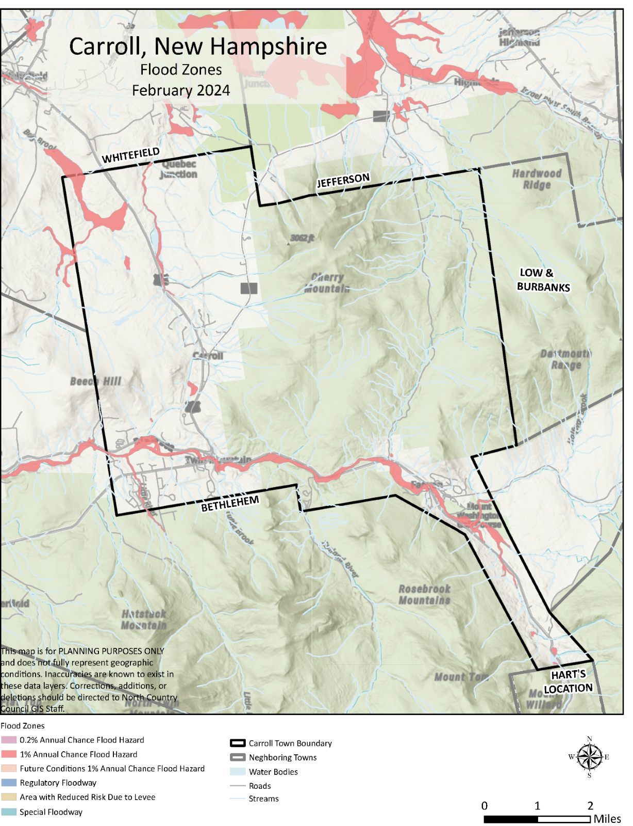

Protecting and Preserving the Environment
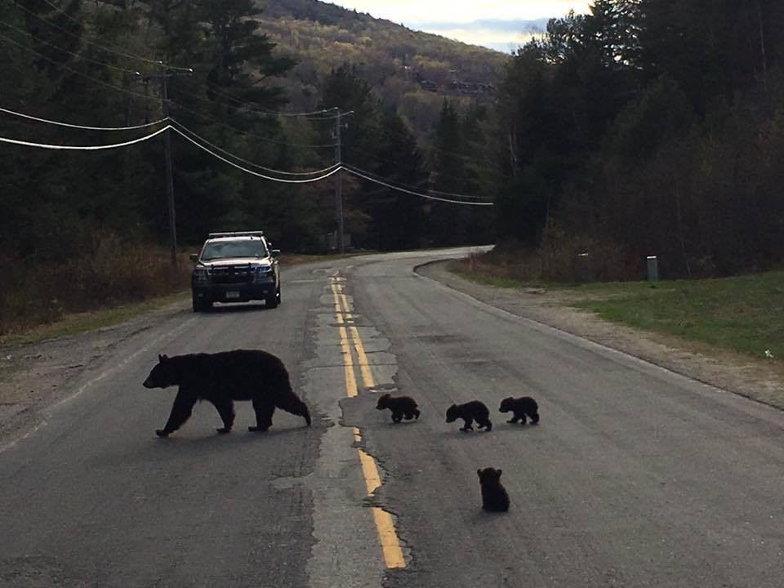
Carroll is home to a number of diverse ecosystems, making it a critical area to protect and preserve. This includes an array of rare and threatened plant and animal species, as well as exemplary natural habitats, and the headwaters to several riverine systems. The Town's landscape includes significant forested areas, wetlands, and high-elevation ecosystems, making it an important area for biodiversity conservation. This section summarizes the current status of rare species and habitats, outlines threats, and highlights ongoing and recommended conservation actions for properties to protect these important ecosystems.
Photo Credit: Town of Carroll, 2025

Rare and Threatened Species
Carroll supports several plant species listed as endangered or threatened by the state, including alpine bistort, button sedge, northern bog violet, and pink shinleaf (endangered), as well as broad-leaved twayblade, Canadian single-spike sedge, Lindley’s American-aster, Loesel’s wide-lipped orchid, heart-leaved twayblade, peat moss, and parasol sedge (threatened). Among animals, the Canadian lynx is both state-endangered and federally threatened, while the American marten and northern bog lemming are of special concern. Kennedy’s emerald, an invertebrate, is also of special concern. Table 4 includes the listed species or communities that are threatened or endangered.

Table 4: Rare and Threatened Species in the Town of Carroll
Plant / Animal | Species or Community | Threatened/Endanger Status
Plant | Alpine bistort | NH - Endangered
Plant | Broad-leaved twayblade | NH – Threatened
Plant | Button sedge | NH - Endangered
Plant | Canadian single-spike sedge | NH – Threatened
Plant | Heart-leaved twayblade | NH – Threatened
Plant | Lindley’s American aster | NH – Threatened
Plant | Loesel’s wide-lipped orchid | NH – Threatened
Plant | Northern bog violet | NH - Endangered
Plant | Parasol sedge | NH - Endangered
Plant | Peat moss | NH – Threatened
Plant | Pink shinleaf | NH – Endangered
Animal (vertebrate) | American marten | NH – Special Concern
Animal (vertebrate) | Canadian lynx | NH – Endangered; US – Threatened
Animal (vertebrate) | Northern Bog Lemming | NH – Special Concern
Animal (invertebrate) | Kennedy’s Emerald | NH – Special Concern
Source: NH Natural Heritage Bureau’s 2020 report on Rare Plants, Rare Animals and Exemplary Natural Communities in New Hampshire Towns: https://www.nh.gov/nhdfl/documents/town-lists.pdf

Habitat Distribution and Protection

Carroll encompasses 32,188 acres, with the largest habitats being northern hardwood conifer forest (18,260 acres), lowland spruce-fir forest (5,982 acres), and high elevation spruce-fir forest (3,525 acres). Wetlands, marshes, and open water further enhance the town's ecological diversity. The state prioritizes the highest quality habitats by tiers. Table 5 outlines the three tiers and how many acres in Carroll are protected, and Map 3 indicates where these tiers are located throughout the Town. Not surprisingly, most of the highest quality habitats are in the White Mountains National Forest and along major waterways like the Israel and John Rivers, and undeveloped parts of the Ammonoosuc River west of the Town Center.
Photo Credit: Paula Murphy, 2025
Table 5: Habitat Tiers Protected/Conserved in Carroll
Tiers | Total Acres | Acres Conserved | Percentage Conserved
TEIR 1 (best in the State) | 6,833 | 5,487 | 80.3%
TEIR 2 (best in ecoregion) | 5,121 | 4,004 | 78.2%
TEIR 3 (Supporting Landscapes) | 13,281 | 7,018 | 52.8%
TOTAL | 32,188 | 16,509 | 51.3%
Source: NH Wildlife Action Plan | State of New Hampshire Fish and Game
Overall, 51% of Carroll’s land is under some form of conservation, significantly higher than the statewide average for rare species occurrences, of which only about 37% are protected.

Map 3. Wildlife Habitat Location by Tier
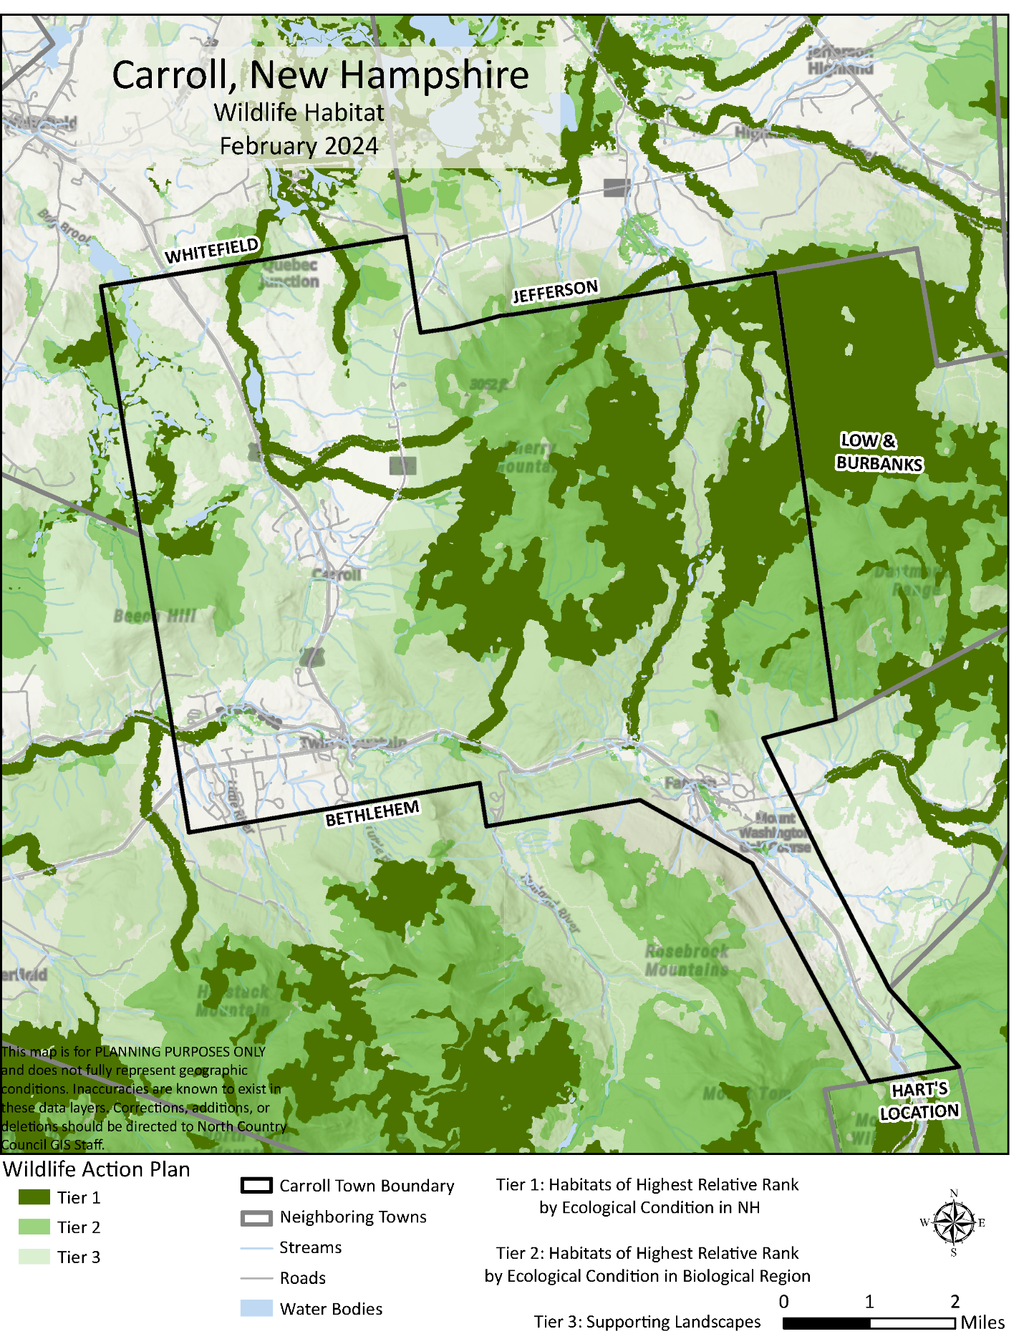

Key Threatened Species and Recent Trends
White-Nose Syndrome in Bats: Since 2012, white-nose syndrome (WNS) has devastated bat populations, with over 12.7 billion bats lost in the Northeast. The state-endangered little brown bat and the federally threatened northern long-eared bat have suffered catastrophic declines, with no sign of recovery as of recent surveys. Bats are vital for insect control and ecosystem health.
Decline of Native Bees: Long-term studies show drastic declines in native bumblebee species, including a 96% drop in the yellow bumblebee and a 71% decline in the yellow-banded bumblebee over the last 150 years. Declines are linked to climate change, land-use change, and competition with non-native honeybees, which may spread disease.
Conservation Actions and Recommendations
Habitat Protection: Continue prioritizing the conservation of Tier 1 and Tier 2 habitats, and increase efforts to protect unprotected rare species occurrences, especially wetlands and high-elevation forests.
Species Monitoring: Support ongoing monitoring of rare plant and animal populations, particularly bats and pollinators, to detect trends and inform management.
Public Engagement: Encourage residents to steward wildlife on their properties, such as by maintaining bat roosts and planting native flowering plants for pollinators.
Disease Management: Follow state and federal guidance on cave closures and decontamination to prevent the spread of WNS. Support research into treatments and resistance in bat populations.
Climate Adaptation: Integrate climate resilience into land management, recognizing that species and habitats may shift in response to changing conditions.
Habitat Loss and Fragmentation: Although Carroll has a high percentage of conserved land, ongoing development and changes in land use threaten remaining unprotected habitats and the species that depend on them.
Water Resources
Water Stewardship Priorities
- Expand riparian buffers along the Ammonoosuc River to stabilize banks and filter pollutants, per NH’s Shoreland Protection Act.
- Address fish passage barriers in tributaries to restore brook trout habitats.
- Continue annual monitoring of the closed Carroll Landfill to prevent groundwater contamination

Surface Water Systems
Carroll’s water resources are dominated by the Ammonoosuc River, a designated river under the NH River Management Program, which supports recreational activities, aquatic habitats, and regional economic assets. The Connecticut River Watershed encompasses most of Carroll, with smaller areas draining into the Saco River. Streams like Tuttle Brook and Johns River contribute to surface water networks, though some face fish passage barriers for brook trout. Map 4 shows the water resources in Carroll.

Groundwater & Municipal Supply
Twin Mountain’s municipal water is sourced from Cherry Mountain and Little River aquifers, while Bretton Woods relies on water supplied by the Abenaki Water Company. High-yield aquifers along Route 302 and Paquette Drive are protected by Carroll’s Aquifer Protection District. The Town adopted the Aquifer Protection District zoning ordinance in 2004. This district is an overlay district, which means it imposes additional regulations on top of the existing zoning districts in areas with significant aquifers. Specifically, the ordinance designates areas where regulated substances, solid waste, and industrial/commercial activities are restricted to protect the aquifers. Map 4 shows the primary aquifers in Carroll.

Water Quality Threats
There are three key threats to Carroll’s water quality systems:
- Nonpoint pollution from road runoff, construction sites, and lawns.
- Underground storage tanks (USTs): Seven sites in Carroll have documented leaks requiring remediation.
- Fluvial erosion along the Ammonoosuc River, exacerbated by extreme weather, has prompted studies to identify hazard zones and restoration strategies.
Map 4. Water Resources
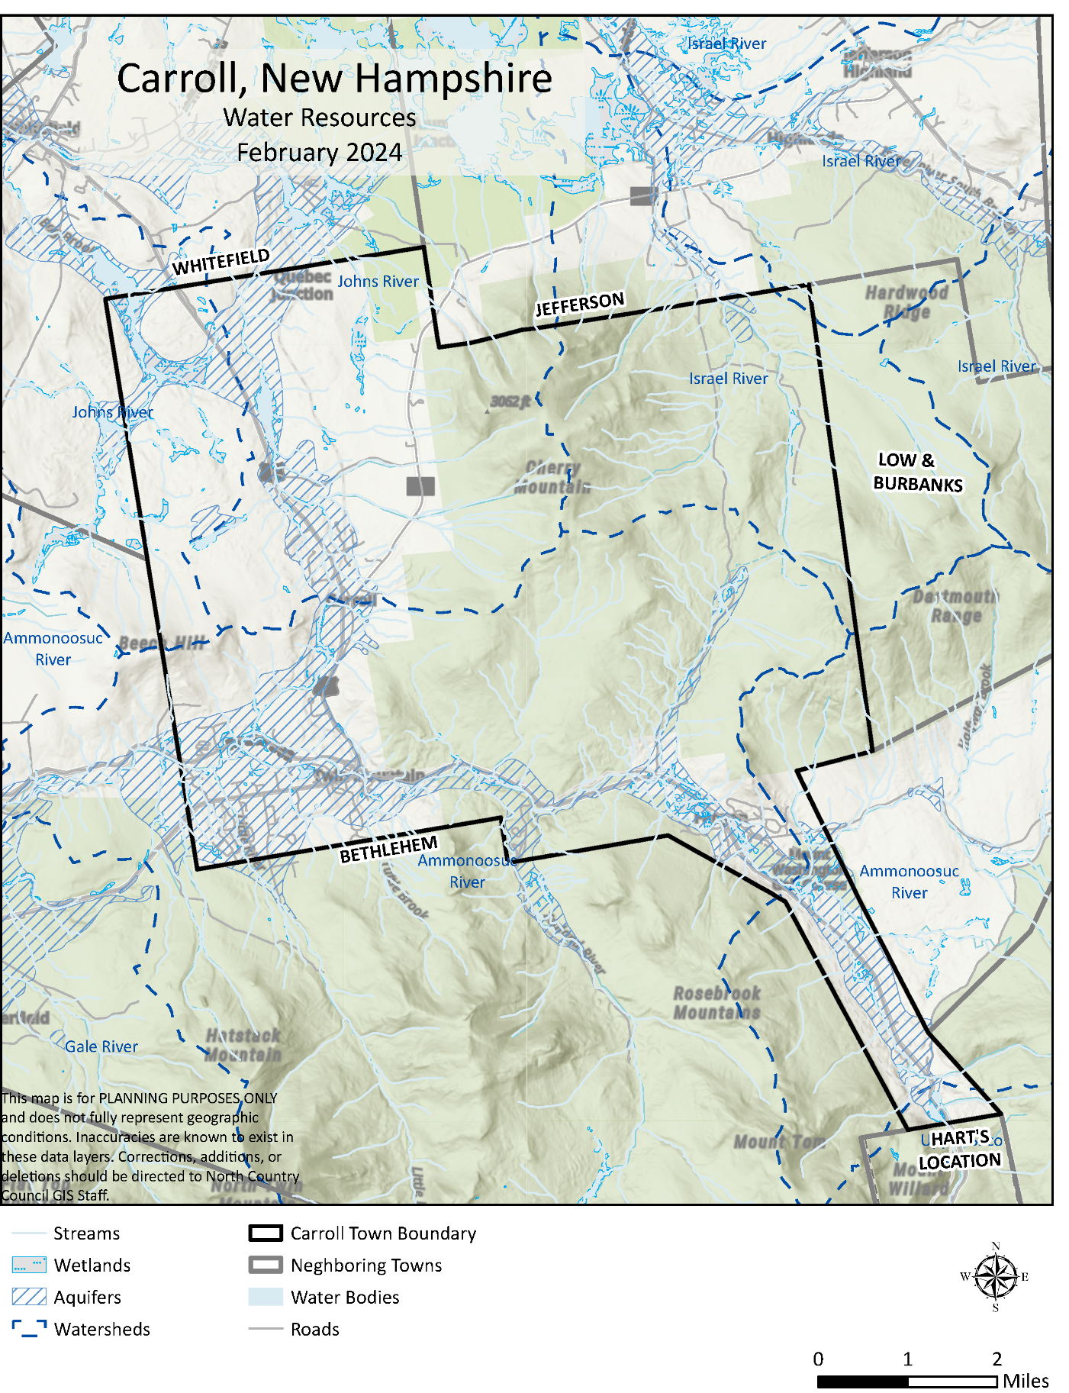

Implementation Strategy
The culmination of a Master Plan is the Implementation Strategy. This Strategy is the blueprint that Carroll can use to achieve our Vision. This Implementation Strategy includes Goals and Actions for each of the 5 Chapters, including the status of the Action, who to partner with to achieve the Action and whether it requires a zoning change. It is available as an Excel spreadsheet so the Town can regularly assess progress and determine what the priorities are for each of the partners. This is a living document, which should be updated regularly by the Planning Board.
Goals | Actions | Action Status  (Completed, In Progress or Not Started) | Requires Zoning Change  (Y or N) | Partners Involved
Accommodations
Goal 1: Increase affordability and accessibility of housing | Action 1.1: Encourage the adoption of Inclusionary Zoning and Workforce Housing Ordinances | Not Started | Y | PB and ZBA
Goal 1: Increase affordability and accessibility of housing | Action 1.2: Partner with a non-profit to identify a site for new housing | Not Started | N | AHEAD and Habitat for Humanity
Goal 1: Increase affordability and accessibility of housing | Action 1.3: Audit the Ordinance to determine potential barriers for Accessory Dwelling Units and update to allow by-right in appropriate zoning districts | Not Started | Y | PB and ZBA
Goal 1: Increase affordability and accessibility of housing | Action 1.4: Explore a zoning change to allow for the conversion of existing residential structures into multi-family uses | Not Started | Y | PB and ZBA
Goal 1: Increase affordability and accessibility of housing | Action 1.5: Build connections with local developers to encourage new housing projects | Not Started | N | PB, AHEAD, Habitat for Humanity
Goal 1: Increase affordability and accessibility of housing | Action 1.6: Adopt Design Standards to ensure that new development and conversions are consistent with Carroll’s character | Not Started | Y | PB and ZBA
Goal 2: Manage year-round housing with seasonal visitors | Action 2.1: Adopt a short-term rental ordinance | In Progress | Y
Goal 2: Manage year-round housing with seasonal visitors | Action 2.2: Create and implement a permitting system for existing and new short-term rentals | In Progress | N | PB, ZBA, and SB

Goals | Actions | Action Status  (Completed, In Progress or Not Started) | Requires Zoning Change  (Y or N) | Partners Involved
Building Business
Goal 3: Increase the number of businesses in Carroll | Action 3.1: Create a permitting instruction guide that simplifies the process for prospective business owners in Town | Not Started | N | PB
Goal 3: Increase the number of businesses in Carroll | Action 3.2: Offer incentives to new businesses which include tax breaks, micro-loans, and discounted fees and permits | Not Started | N | Selectboard
Goal 3: Increase the number of businesses in Carroll | Action 3.3: Coordinate with the Chamber of Commerce to create a resource that assists local businesses with navigating the challenges of creating legal and potentially profitable enterprises. This office can help with business plans, bookkeeping, and obtaining proper permits. | Not Started | N | Twin Mountain-Bretton Woods Chamber of Commerce
Goal 3: Increase the number of businesses in Carroll | Action 3.4: Create an entrepreneurial ecosystem, which includes complimentary businesses that support each other | Not Started | N | Twin Mountain-Bretton Woods Chamber of Commerce
Goal 3: Increase the number of businesses in Carroll | Action 3.5: Leverage the Town’s natural assets and capitalize on the outdoor recreational opportunities | In Progress | N | CC and Twin Mountain-Bretton Woods Chamber
Goal 4: Support Existing Businesses | Action 4.1: Work with the Chamber of Commerce to promote existing businesses | Not Started | N | Twin Mountain-Bretton Woods Chamber
Goal 4: Support Existing Businesses | Action 4.2: Create an Economic Development Plan that supports existing business (including expansion) and recruits new businesses that complement the existing business ecosystem | Not Started | N | PB, Selectboard, Twin Mountain-Bretton Woods Chamber
Goal 4: Support Existing Businesses | Action 4.3: Improve infrastructure and connectivity, including maintaining and upgrading transportation networks, enhancing internet connectivity through fiber-optic installations or partnerships with telecom companies for better broadband service | Not Started | N | Selectboard and Public Works

Goals | Actions | Action Status  (Completed, In Progress or Not Started) | Requires Zoning Change  (Y or N) | Partners Involved
Connecting Carroll
Goal 5: Ensure roadways are safe for all users. | Action 5.1: Utilize traffic calming strategies that slow vehicle speeds along Main Street and village areas, including roundabouts, road narrowing, colorful crosswalks and flashing speed feedback signs | Not Started | N | North Country Council and NHDOT
Goal 5: Ensure roadways are safe for all users. | Action 5.2: Create and enhance pedestrian routes along Main Street and village areas | Not Started | N | NHDOT
Goal 5: Ensure roadways are safe for all users. | Action 5.3: Maintain and improve roadway conditions | In Progress | N | NHDOT
Goal 5: Ensure roadways are safe for all users. | Action 5.4: Consider sharrows or other road markings/indicators to encourage bicycle use and safety | Not Started | N | NHDOT
Goal 6: Preserve the quality and sustain present levels of availability of the Town's water resources | Action 6.1: Encourage development where the Town's water system is and can be improved | In Progress | N | Selectboard, PB and Public Works
 | Action 6.2: Determine capability of land for development by the carrying capacity of the soils to sustain increased development | In Progress | N | PB, CC
Goal 7: Improve and maintain municipal infrastructure like water and utilities | Action 7.1: Manage residential growth based on municipal infrastructure capacity | In Progress | Y | PB, Selectboard and Public Works
 | Action 7.2: Encourage residents and businesses to implement water and wastewater reduction strategies | In Progress | N | Selectboard and Public Works
Goal 8: Achieve sustainable waste management and renewable energy integration. | Action 8.1: Encourage residents and businesses to implement water and wastewater reduction strategies | In Progress | N | Selectboard and Energy Committee
 | Action 8.2: Encourage residential and commercial installation of renewable energy, like solar, wind, and geothermal | In Progress | N | Selectboard and Energy Committee
 | Action 8.3: Promote electric vehicle charging stations in public and private locations | Not Started | N | Selectboard and Energy Committee
 | Action 8.4: Promote waste-reduction strategies (recycling, composting, reuse/reduce methods) amongst residents and visitors | In Progress | N | Transfer Station and Selectboard
Goal 9: Enhance and expand community facilities and services to meet the evolving needs of Carroll residents, focusing on improving accessibility, efficiency, and quality of life. | Action 9.1: Continue to adhere to the Town's Comprehensive Public Facilities Inventory that plans for upgrades and maintenance | In Progress | N | All committees, boards, and departments
 | Action 9.2: Increase and maintain communication between Town Committees and important stakeholders | In Progress | N | All committees, boards, and departments
 | Action 9.3: Increase municipal planning services to manage the influx of development and administrative needs | Not Started | N | Selectboard

Goals | Actions | Action Status  (Completed, In Progress or Not Started) | Requires Zoning Change  (Y or N) | Partners Involved
Designing Our Community
Goal 10: Create an inviting town center and Main Street | Action 10.1: Implement adaptive reuse practices to convert old buildings to new uses | Not Started | Y | PB, ZBA, Selectboard, and Historical Society
Goal 10: Create an inviting town center and Main Street | Action 10.2: Establish compatible building styles and themes that are consistent with town character and bring attention to Main Street | Not Started | Y | PB, ZBA, Selectboard, and Historical Society
Goal 10: Create an inviting town center and Main Street | Action 10.3: Inventory dilapidated/abandoned buildings to determine value and potential steps to remove or restore | Not Started | N | Building Inspector and Historical Society
Goal 10: Create an inviting town center and Main Street | Action 10.4: Inventory , restore and preserve important historical buildings | In Progress | N | Selectboard, PB, Historical Society
Goal 11: Implement sustainable development practices that preserve the town's natural resources, rural character, and quality of life while promoting responsible growth | Action 11.1: Update zoning ordinance to include site design and stormwater runoff reduction techniques such as minimizing impervious surface and low impact development strategies | In Progress | Y | PB and ZBA
 | Action 11.2: Conduct a Build-Out Analysis of the Town to explore current land uses, project future population and determine buildable land remaining for future land uses | Not Started | N | PB
 | Action 11.3: Align development with available water and wastewater infrastructure to avoid overburdening resources | In Progress | Y | PB, ZBA, and Selectboard
Goal 12: Create a vibrant and inclusive community that offers a range of public events and services that cater to the needs and interests of residents, while promoting local economic growth and social well-being | Action 12.1: Enhance recreational facilities and events by: 1) Developing and maintaining year-round recreational facilities that support activities such as hiking, skiing, biking, and more; and 2) Creating more public spaces for community gatherings and events | Not Started | N | Selectboard and Public Works
 | Action 12.2: Increase capacity and accessibility of the Post Office | Not Started | N | US Postal Service
 | Action 12.3: Partner with surrounding towns and organizations to organize community events | Not Started | N | Town Committees, Bethlehem, Franconia, Whitefield, Jefferson

Goals | Actions | Action Status  (Completed, In Progress or Not Started) | Requires Zoning Change  (Y or N) | Partners Involved
Environmental Stewardship
Goal 13: Increase and sustainably manage accessible outdoor recreation opportunities for all | Action 13.1: Create an accessible trail system starting at the Recreation Center | Not Started | N | Recreation Department
 | Action 13.2: Encourage the development and maintenance of multi-use trails | Not Started | N | AMC and Northern Forest Center
 | Action 13.3: Promote the safe use of hiking and biking trails in and around Carroll | Not Started | N | NH Office of Outdoor Recreation, NH Tricycle
Goal 14: Limit the impacts of natural disasters | Action 14.1: Annually update town-wide hazard mitigation plan | Not Started | N | All committees, boards, and departments
Goal 14: Limit the impacts of natural disasters | Action 14.2: Limit or prohibit development in the floodplain and wetland buffers | In Progress | Y | CC, PB and ZBA
Goal 14: Limit the impacts of natural disasters | Action 14.3: Incorporate resilience strategies into new development and renovations, including building materials, site design, building orientation, height, fire retardant strategies, etc. | Not Started | Y | CC, PB, ZBA, and Selectboard
Goal 15: Preserve diverse ecosystems, maintain water quality, mitigate climate change impacts, and promote sustainable land use practices | Action 15.1: Maintain and expand conservation easements to protect critical habitats such as those in the White Mountain National Forest and Pondicherry National Wildlife Refuge | In Progress | N | PB, ZBA, and Selectboard
 | Action 15.2: Promote sustainable forest management practices to preserve carbon-storing ecosystems and combat invasive species | Not Started | N | CC, PB, ZBA, and Selectboard
 | Action 15.3: Partner with organizations and state agencies to provide workshops on stewardship practices for landowners | Not Started | N | NH Office of Outdoor Recreation

Appendix A – Data
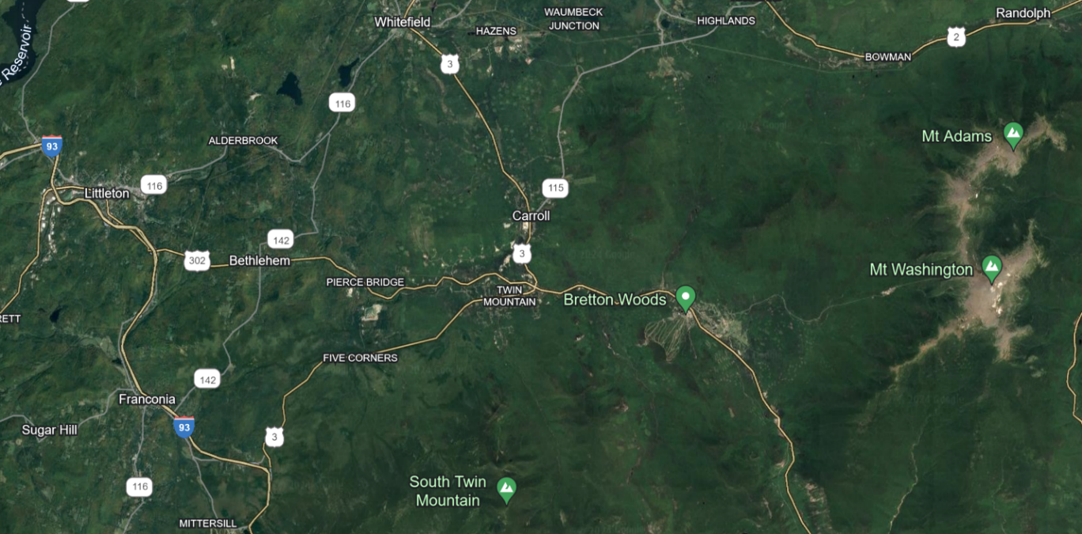

 |  |  |  |  |  |  | 
 | Population | Median Age | Older Population 65+ | Veterans | Education  Bachelor’s Degree or Higher | Median Household Income | Poverty Rate
Carroll | 820 | 59 | 32% | 12% | 32% | $77,500 | 4.8%
Coos | 31,268 | 50 | 25% | 10% | 20% | $55,247 | 11.6%

 |  |  |  |  |  | 
 | Housing Units | Median Gross Rent | Occupied Housing Units | Median Purchase Price | Square Land Miles | Square Inland Water Miles
Carroll | 912 | $980 | 379 | $492,000 | 50.11 | .18
Coos | 20,444 | $825 | 13,908 | $195,000 | 1,794.41 | 36.79

 | Carroll
 | Total Land Ac. | Total Current Use Ac. | Total Conservation Ac. | Federal
 | 32,171.41 | 9,996.66 | 17,589.24 ® | 16,714 +/-
Source: https://data.census.gov/profile/Carroll_town,_Coos_County,_New_Hampshire?g=060XX00US3300710100, https://data.census.gov/profile/Coos_County,_New_Hampshire?g=050XX00US33007, https://www.nhhfa.org/, Image Google Earth, Dept Revenue 2022 Current Use Rpt and NH OPD

CARROLL MASTER PLAN DATA UPDATE SUMMARY
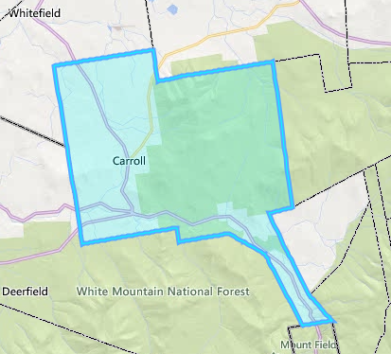
Master Planning is an important tool for shaping the future of the Town of Carroll. The Plan is a roadmap for how the community has changed and may grow. Data is vital in Master Planning, and gathering information relevant to the community is essential to developing a Master Plan. Part of updating the Plan is to consider and better understand who lives in the Town of Carroll, how the land is used, how people move around, what the environment is like, how people live, and more. Looking at various data sets and demographics helps you look at your Town as a whole and will lay the groundwork for updating Master Plan Chapters, establishing goals, revising the vision, and updating a plan for the future.
This summary sheet contains updated data for the Planning Board Master Plan Committee to discuss and use in updating the 2015 Carroll Master Plan. The 2015 Master Plan has over 25 data points and topics ranging from population and income to threatened and endangered species.
The demographic data, such as population, median home purchase price, and income, in the 2015 Master Plan were displayed as the Littleton Labor Market Area (LMA). In 2015, displaying data this way was likely the best way to see and understand data trends for the Town of Carroll and surrounding areas. LMAs were based on data on commuting patterns and were used by many federal and state agencies to organize and analyze socioeconomic data.
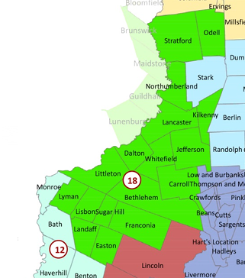
In 2015, the Littleton LMA contained 17 towns and unincorporated places.
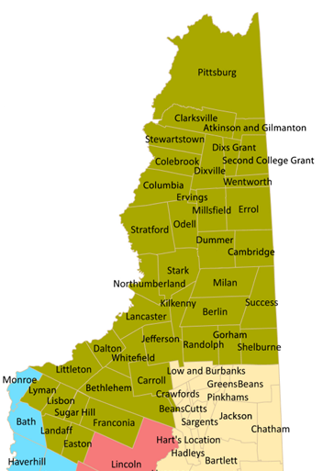
The LMA, which Carroll was a part of, has transitioned from the Littleton LMA to the Northern NH LMA, encompassing 39 towns and unincorporated places. This shift in geographical context has implications for our data analysis and understanding of Carroll's trends.
Given the change in the LMA boundaries and the evolving demographics, industry landscape, and work options (remote/hybrid), we have taken a new approach to analyzing The Town of Carroll’s data. This approach involves comparing the Town of Carroll's data with surrounding towns, the County, or the state, providing a more accurate reflection of The Town of Carroll's current trends.
Following the 04/17/2024 Planning Board Meeting and the initial data discussion, the NCC staff has reviewed various data sets and sources. Most of the data we present today is from the US Census 5-Year Estimates, which offer the most reliable and comparable data from year to year.

HOW TO USE THIS SUMMARY:
In the North Country Council’s role in assisting the Planning Board with its update to the Master Plan, this data summary is written to guide discussion of changes to the plan chapters based on changing conditions. The Planning Board may consider using them in the following ways:
- The numbers, charts, and tables can be the basis for the information included in the update. As we move through this update process, this information will be directly incorporated into the Master Plan draft.
- The data can help Planning Board members consider what is changing and what is remaining constant in the community. Reflecting on these local conditions and population shifts can help them consider an update to the community vision, goals, and objectives of Carroll’s Master Plan.
- The data here can also help inform specific questions or topics you may want to discuss with community members during the master plan update's outreach and engagement phases.

Population Trends
- The total population of the Town of Carroll has grown 31% since 2010; this is the highest growth rate of the surrounding communities, including Coos County, which experienced a population outmigration of 6%.
- From 2000 to 2022, The Town of Carroll experienced a growth of only 17%. However, it is important to note that this compares US Census ACS 5-year estimates to US Census Decennial and Historic Data from OPD. At the same time, Coos County experienced an outmigration of 5% of the population.
Total Population
 | 2010 | 2020 | 2022 | % Change 2010 to 2022
Coos County | 33,445 | 31,486 | 31,430 | -6%
Bethlehem | 2,493 | 2,591 | 2,512 | 1%
Littleton | 5,949 | 5,916 | 6,021 | 1%
Grafton County | 88,356 | 90,331 | 90,836 | 3%
NH | 1,313,939 | 1,355,244 | 1,379,610 | 5%
Whitefield | 2,220 | 2,141 | 2,484 | 12%
Carroll | 608 | 773 | 795 | 31%
Source: US Census ACS 5-Year Estimates | DPO5

Source: US Census ACS 5-Year Estimates (2010 to 2022) and US Census OPD Historic Population

Source: US Census ACS 5-Year Estimates|DPO5

- The Town of Carroll is growing older. The median age in 2022 is 58, 7 years older than in 2010.
- The Town of Carroll also has the oldest median age in the surrounding area and Coos County.
- The age cohort graphs on the next page show that approximately 22% of the town of Carroll's total population falls within the retirement age range of 65 – 74, 5% higher than the county's same-age cohort.
- Between 2020 and 2022, Carroll's younger population, ages under 5 to 19, stayed between 0% and 8% of the total population. This is slightly above the County's, but only by 4%.

Source: US Census ACS 5-Year Estimates | DPO5

- According to the NH Business and Economic Affairs, Office of Planning and Development, the population of the Town of Carroll is expected to increase slightly until 2025 and then progressively decline until the year 2050.
- Population projections for surrounding areas indicate that Carroll, Whitefield, and Coos County will see a population decline in 2030, while NH, Grafton County, Bethlehem, and Littleton are projected to increase in population until 2024 when they will begin to decline slightly.
Source: NHBEA OPD Data https://www.nheconomy.com/getmedia/0205c62d-9c30-4b00-9c9e-d81d8f17b8b3/NH-Population-Projections-2020-2050-Final-Report-092022.pdf

- Xxxxx
- Xxxxx
- Xxxxx
- Xxxxx

Population Projects for the State, North Country Counties and Surrounding Communities
Source: NHBEA OPD Data https://www.nheconomy.com/getmedia/0205c62d-9c30-4b00-9c9e-d81d8f17b8b3/NH-Population-Projections-2020-2050-Final-Report-092022.pdf

Median Household Income

US Census ACS 5-Year Estimates |DP04
- Carroll’s Median Household Income increased between 2020 to 2022 increased by $17,083 or 22%. This is higher than the 11% increase in Coos County and the 14% increase experienced by NH.
- Of the surrounding towns, Carroll has experienced the second-largest growth, with Bethlehem experiencing the largest increase of 31% during the same period.

Source: New Hampshire Housing Finance Authority, 2022
- .A popular standard used for budgeting rent is to follow the 30% rule, where you spend a maximum of 30% of your monthly income before taxes (your gross income) on your rent.
- In 2022, the Town of Carroll had 75 renter-occupied housing units. Of those, 23% were paying more than 30% of their HHI on rent.

Industry & Employment
- The Town of Carroll’s largest employers, as listed by NH Employment Security, Economic Labor Market Information Bureau (ELMIB), are the Mount Washington Hotel, Bretton Woods Ski Area, and NHDOT (including NH State Police & Highway Maintenance). It is noted that the municipality supplies ELMIB with this information. In addition to those listed by ELMIB, the Mount Washington Cog, UPS Customer Center, and AMC Highland Center can also be considered larger employers.
Northern NH Labor Market Area | June 2023
 | Entry Level Wage | Mean (Average) Wage | Median Wage | Experienced Wage
Total Occupations | $14.17 | $26.00 | $20.50 | $31.93
Source: www.nhes.nh.gov/elmi/products/documents/wages-nonh.pdf
Source: US Census ACS 5-Year Estimates |DP03

Transportation

Average Daily Traffic
- Each year, NH Department of Transportation (NHDOT) specifies regional locations according to a 3-year rotating cycle. This data is then added to a statewide database that tracks information such as traffic patterns, traffic volumes, and types of vehicles.
Count Number | Location | 1990 | 2000 | 2010 | 2020 | 2023
62075054 | US Route 302 East of Rt 3 & 302 Intersection | 2,500 | NR | 3,026 | 4,033 | 4,075
82075059 | US Rt 3 South of Rt 3 & 302 Intersection | 4,200 | 5,200 | NR | 3,780 | 5,179
62075053 | US Rt 3 North of Rt 3 & 302 Intersection (Near RR Track Crossing) | 3,800 | NR | 5,300 | 5,869 | 6,783
82075055 | US Rt 3 North of Rt 3 & 302 Intersection (Between Parker Rd & Ledoux Dr. | 3,600 | NR | NR | 5,446 | 5,498
82075056 | NH Rt 115 | 2,100 | NR | NR | 2,753 | 4,291
82075060 | Lennon Road | NR | 120 | NR | 137 | 186
82075050 | US Rt 302 East of Rt 3 & 302 Intersection (over Ammonoosuc River) by Base Station Road Intersection | NR | NR | 2,700 | 3,600 | 3,842
82075057 | Base Station Road | 660 | 1,400 | NR | 632 | 1,793
82075058 | Mt Clinton Road | NR | NR | NR | 114 | 102
Source: NHDOT Traffic Count TDCS https://nhdot.public.ms2soft.com/tcds/tsearch.asp?loc=Nhdot&mod=TCDS
NR= No Record

Vehicles Available by Household
Mode of Transportation Carroll 2021
Workers 16 years and over (375)
- 74% Car, Van, Truck (Drove Alone)
- 7% Car, Van, Truck (Carpooled)
- 0% Bicycle
- 6% Walked
- 5% Motorcycle/other
- 8% Worked from home

Source: ACS 5-Year Estimate | S0801 | 2021

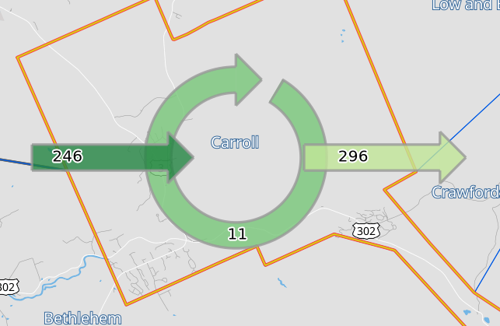
Commuting to Work
Source: 2010 OnTheMap

Changes in Commuting Patterns for Carroll
 | 2010 | 2021 | % Change
Commuting into Carroll for Work | 246 | 685 | 64%
Live in Carroll and Work In Carroll | 11 | 80 | 86%
Commuting out of Carroll for Work | 296 | 284 | -4%
Source: 2021 OnTheMap

- For reference, COVID shutdowns began in March 2020, changing the employment status, commuting patterns, and work locations of many individuals. This shift in individuals' work locations and reorganization of work-life balance is likely the contributor to the 86% increase in those who live and work in Carroll.

Housing

Housing Occupancy, Vacancy, and Unit Type
Town of Carroll Housing Occupancy
 | 2010 | 2020 | 2022
Total housing units | 843 | 984 | 991
Occupied housing units | 288 | 398 | 418
Vacant housing units | 555 | 586 | 573
Owner – Occupied | 248 | 329 | 343
Renter-occupied | 40 | 69 | 75
Source: ACS 5-year Estimates | DP04
- Total housing units increase by 15% from 2010 to 2022.
- Of the 991 total housing units, 58% are vacant, which is directly related to the fact that 53% are used for seasonal use.
- This also relates to the number of short-term rentals identified by AirDNA
Vacancy Status | 2010 | 2020 | 2022
Total Vacant Housing Units | 555 | 586 | 573
For rent | 10 | 12 | 12
Rented, not occupied | 10 | 6 | 6
For sale only | 0 | 6 | 6
Sold, not occupied | 0 | 0 | 0
For seasonal, recreational, or occasional use | 506 | 538 | 525
For migrant workers | 0 | 0 | 0
Other vacant | 29 | 24 | 24
Source: ACS 5-year Estimates | B25004

- It is noted that 36 mobile homes may be seasonal campers or RV that stay in place year-round.
Town of Carroll Housing Unit by Type
 | 2010 | 2020 | 2022
Total housing units | 843 | 984 | 991
1-unit, detached | 484 | 565 | 592
1-unit, attached | 13 | 154 | 152
2 units | 123 | 47 | 40
3 or 4 units | 107 | 73 | 84
5 to 9 units | 83 | 76 | 81
10 to 19 units | 4 | 6 | 6
20 or more units | 0 | 0 | 0
Mobile home | 29 | 63 | 36
Source: ACS 5-year Estimates | DP04

Income and Housing
Town of Carroll Housing Tenure by Income
Owner Occupied Total | 2010 | 2020 | 2022 |  | Renter Occupied Total | 2010 | 2020 | 2022
Owner Occupied Total | 248 | 329 | 343 |  | Renter Occupied Total | 40 | 69 | 75
Less than $5,000 | 9 | 4 | 17 |  | Less than $5,000 | 0 | 0 | 0
$5,000 to $9,999 | 5 | 4 | 2 |  | $5,000 to $9,999 | 0 | 2 | 3
$10,000 to $14,999 | 14 | 8 | 4 |  | $10,000 to $14,999 | 9 | 0 | 0
$15,000 to $19,999 | 4 | 8 | 9 |  | $15,000 to $19,999 | 0 | 0 | 0
$20,000 to $24,999 | 15 | 2 | 8 |  | $20,000 to $24,999 | 0 | 10 | 3
$25,000 to $34,999 | 10 | 21 | 9 |  | $25,000 to $34,999 | 13 | 4 | 9
$35,000 to $49,999 | 44 | 96 | 75 |  | $35,000 to $49,999 | 18 | 4 | 2
$50,000 to $74,999 | 72 | 54 | 43 |  | $50,000 to $74,999 | 0 | 33 | 21
$75,000 to $99,999 | 43 | 45 | 58 |  | $75,000 to $99,999 | 0 | 3 | 17
$100,000 to $149,999 | 32 | 57 | 70 |  | $100,000 to $149,999 | 0 | 11 | 18
$150,000 or more | 0 | 30 | 48 |  | $150,000 or more | 0 | 2 | 2
Source: ACS 5-year Estimates | B25118

- The median income for a household in The Town of Carroll in 2020 was $60,417, and $77,500 for 2022.
- As income increases, the number of homeowners increases. When incomes are lower, there tend to be more renters.
- The Median Home Purchase Price increased 87% in the town of Carroll from 2000 to 2023, higher than in Coos County, surrounding Towns, and New Hampshire.
- From 2020 to 2023, the Median Home Purchase Price in Carroll increased by 30%. This is comparable to Littleton, Coos Count, and the state of NH while still being above Bethlehem and Whitefield.

Median Home Purchase Price
 | 1990 | 2000 | 2010 | 2020 | 2023
Carroll | $80,000 | $79,950 | $169,500 | $420,800 | $600,500
Bethlehem | $79,900 | $90,000 | $135,250 | $208,800 | $249,500
Littleton | $105,048 | $88,000 | $139,200 | $200,000 | $300,000
Whitefield | $75,000 | $71,500 | $117,500 | $220,500 | $260,000
Coos County | $69,900 | $69,950 | $145,000 | $145,000 | $216,000
Grafton County | $104,000 | $104,000 | $185,000 | $231,000 | $355,000
NH | $119,905 | $143,000 | $215,000 | $302,300 | $418,000
NH Housing Finance Authority, Purchase Price Trends

NH Housing Finance Authority, Purchase Price Trends

Short Term Rentals
- According to AirDNA, there are 106 active listings in “Bretton Woods” for short-term rentals, a 6% increase in the past year. 99% of those are rentals of an entire home, and 1% is listed as a private room.
- Within the area identified as “Twin Mountain” on AirDNA, there are 95 active listings. This is a 25% increase in the past year, according to AirDNA. Of the 96 listings, 98% are entire home rentals, and 2% are listed as a private room.
- Source AirDNA https://www.airdna.com/

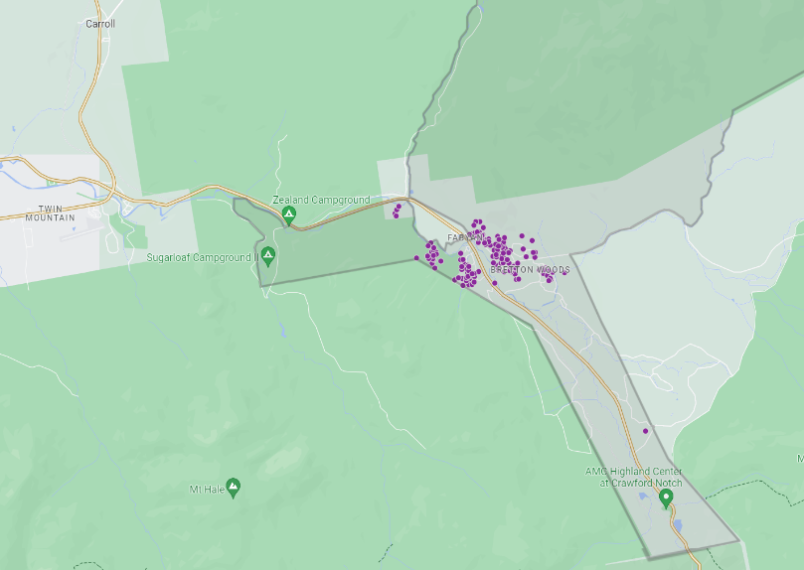
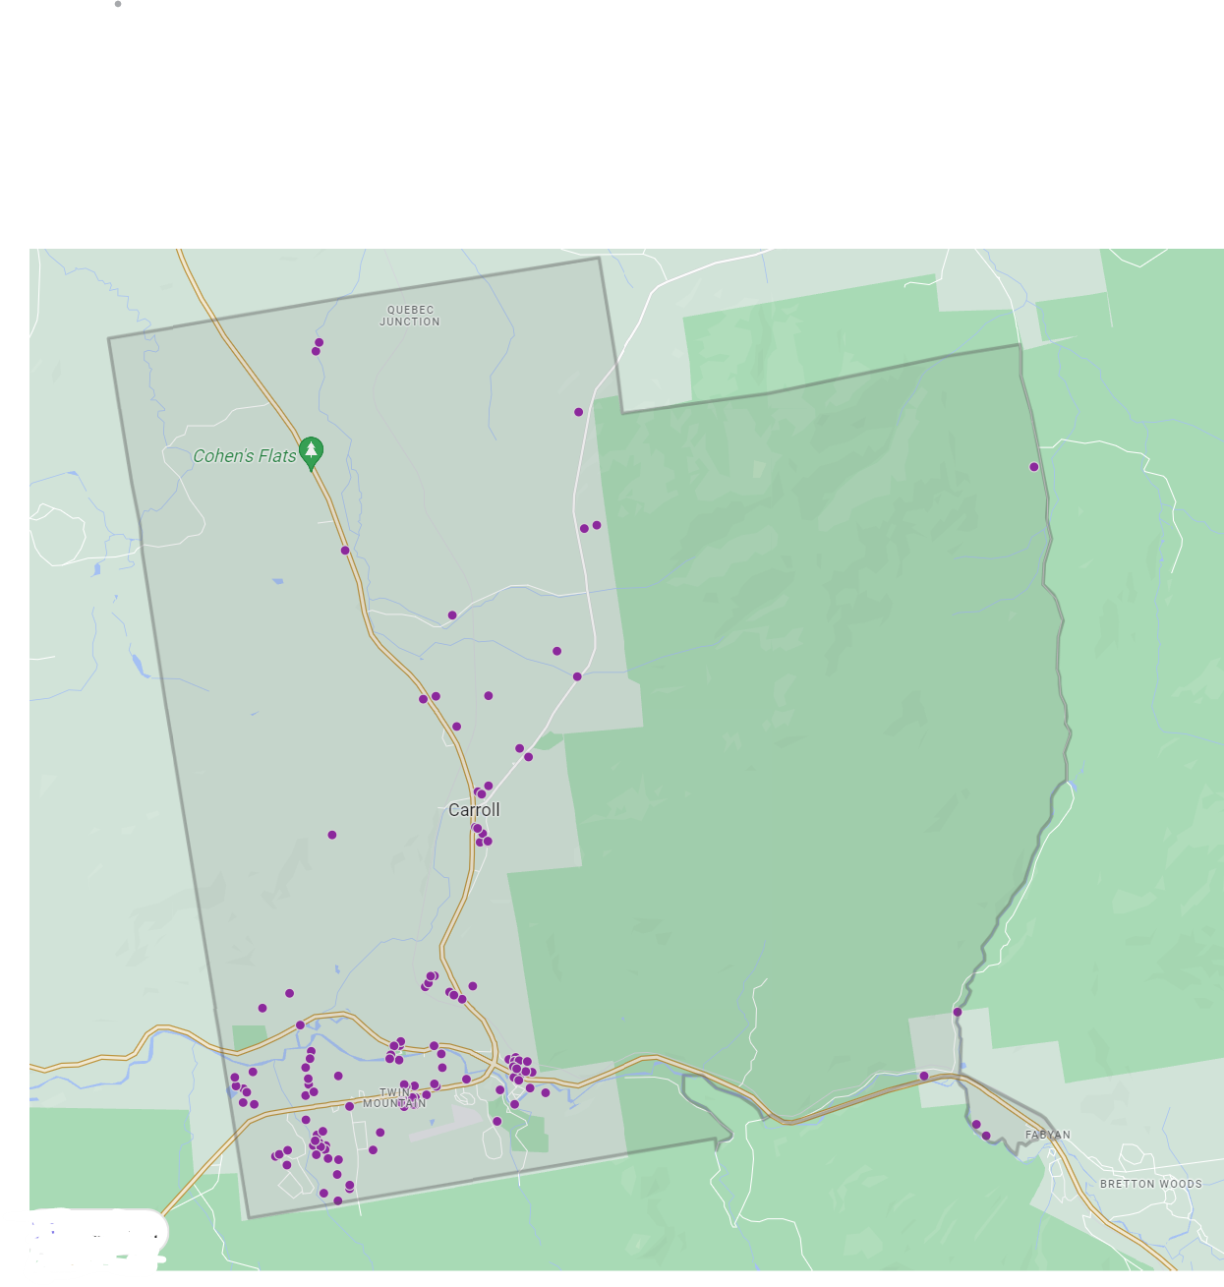
Bretton Woods, AirDNA Screenshot, May 2024
Twin Mountain, AirDNA Screenshot, May 2024

Building Permits
- The Town of Carroll Planning Board provided building permit records for 2019 to 2024. These records listed the date, permit number, applicant name, map/lot number, address of activity, permit amount, and project value. While the information indicated the activity description, it did not include a permit type. North Country Council Staff organized data in the following manner.
- Building permit data from the Office of Planning and Development, NHBEA, was also captured.

Town of Carroll Building Permits | Town Records
 |  | 2019 | 2020 | 2021 | 2022 | 2023
New Single Home |  | 10 | 4 | 12 | 9 | 13
Total Renovation of Existing Home & Cabins |  | 6 | 0 | 1 | 1 | 0
Foundation Only |  | 2 | 0 | 2 | 4 | 1
New Multi-Unit Home | 0 |  | 0 | 0 | 0 | 3
Construction New Building | 0 |  | 0 | 0 | 1 | 0
Source: Town of Carroll, (2019-2023)

Housing Units Authorized by Permit
Year | 2010 | 2011 | 2012 | 2013 | 2014 | 2015 | 2016 | 2017 | 2018 | 2019 | 2020 | 2021
Single-Family | 4 | 9 | 6 | 4 | 6 | 5 | 6 | 11 | 5 | 17 | 6 | 11
Multi-family | 0 | 0 | 1 | 2 | 0 | 0 | 10 | 8 | 9 | 0 | 0 | 3
Manufactured | 0 | 0 | 1 | 0 | 0 | 0 | 10 | 0 | 0 | 0 | 0 | 0
Total | 4 | 9 | 8 | 6 | 6 | 5 | 26 | 19 | 14 | 17 | 6 | 14
Source: Office of Planning and Development, NH BEA, (2010-2021)

It is important to note that data on the Housing Snapshot below may not align with the numbers presented in the data topics above. This difference is attributed to a difference in sources and years. This snapshot is included only for discussion purposes to determine additional housing data the group may want to include while updating the Master Plan.
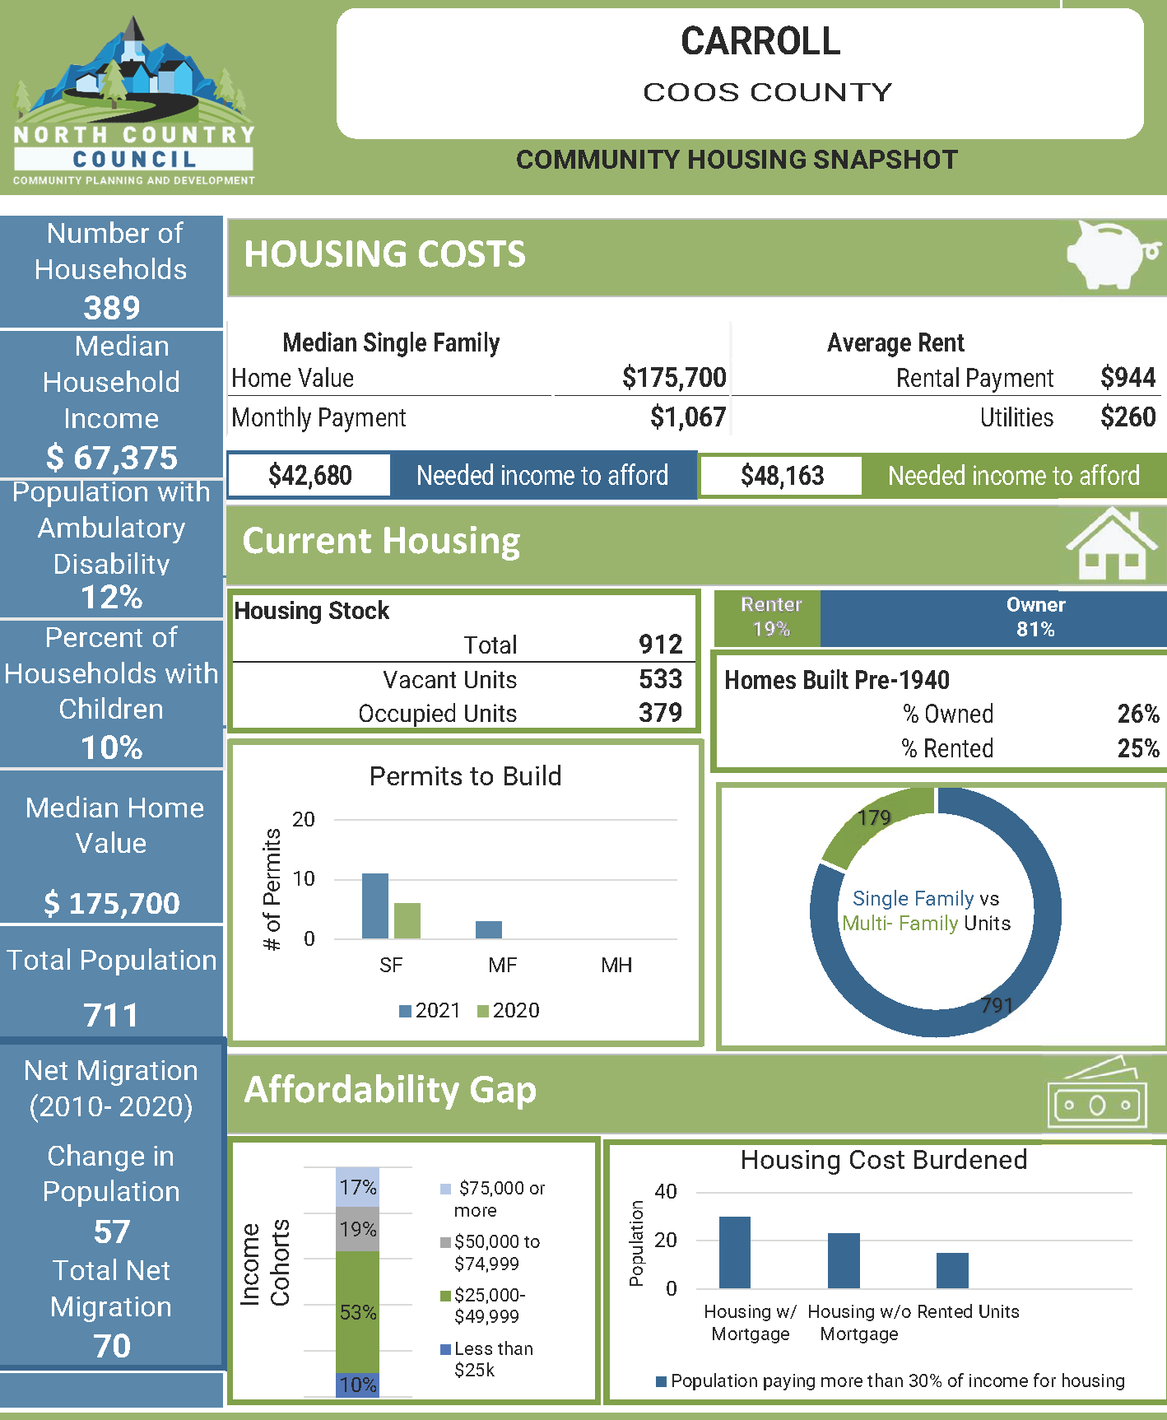

Appendix B – Maps

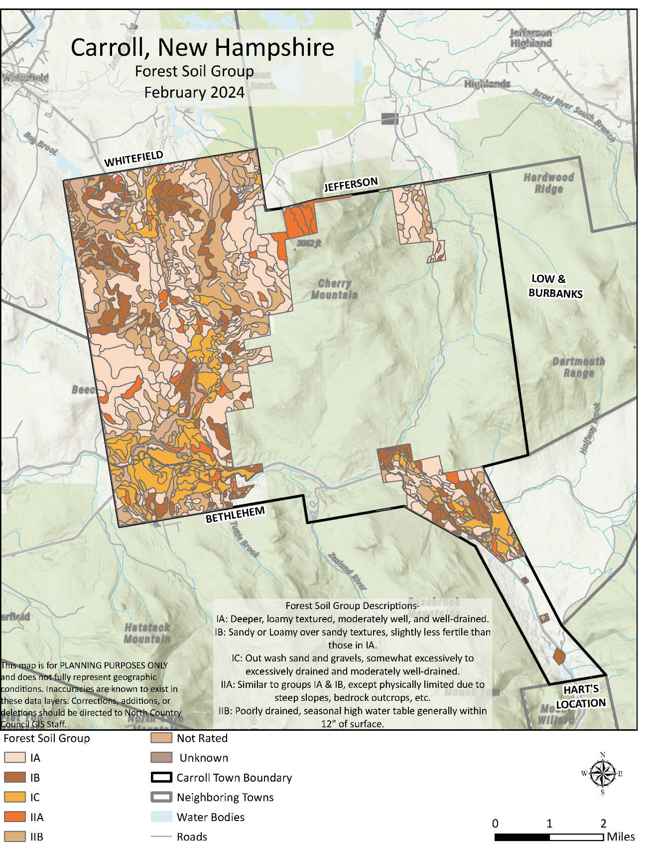
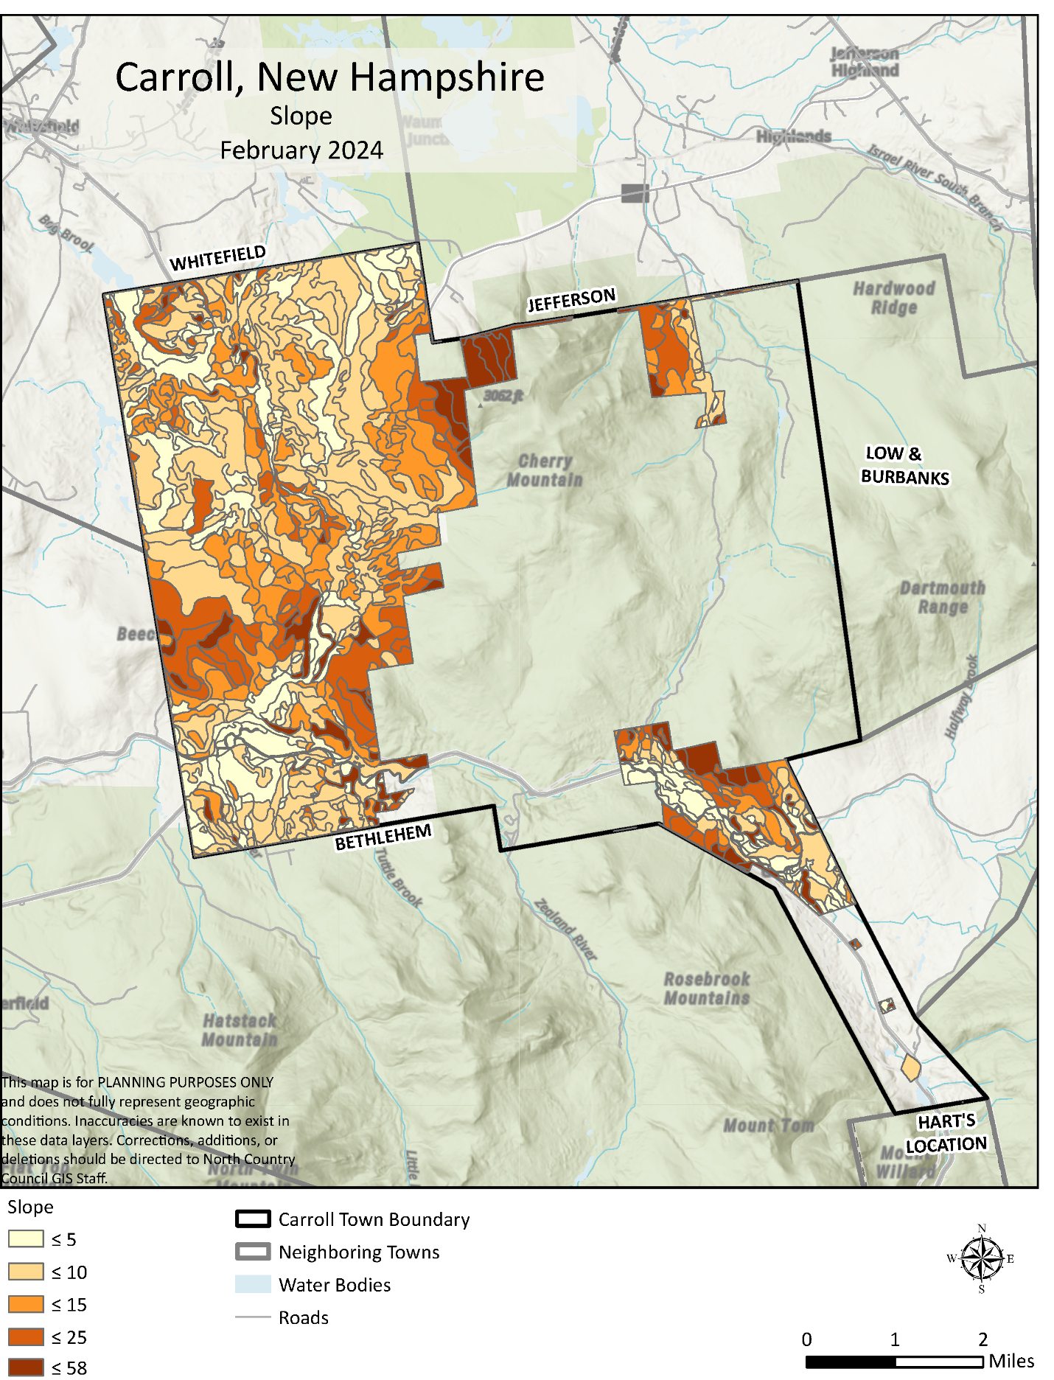
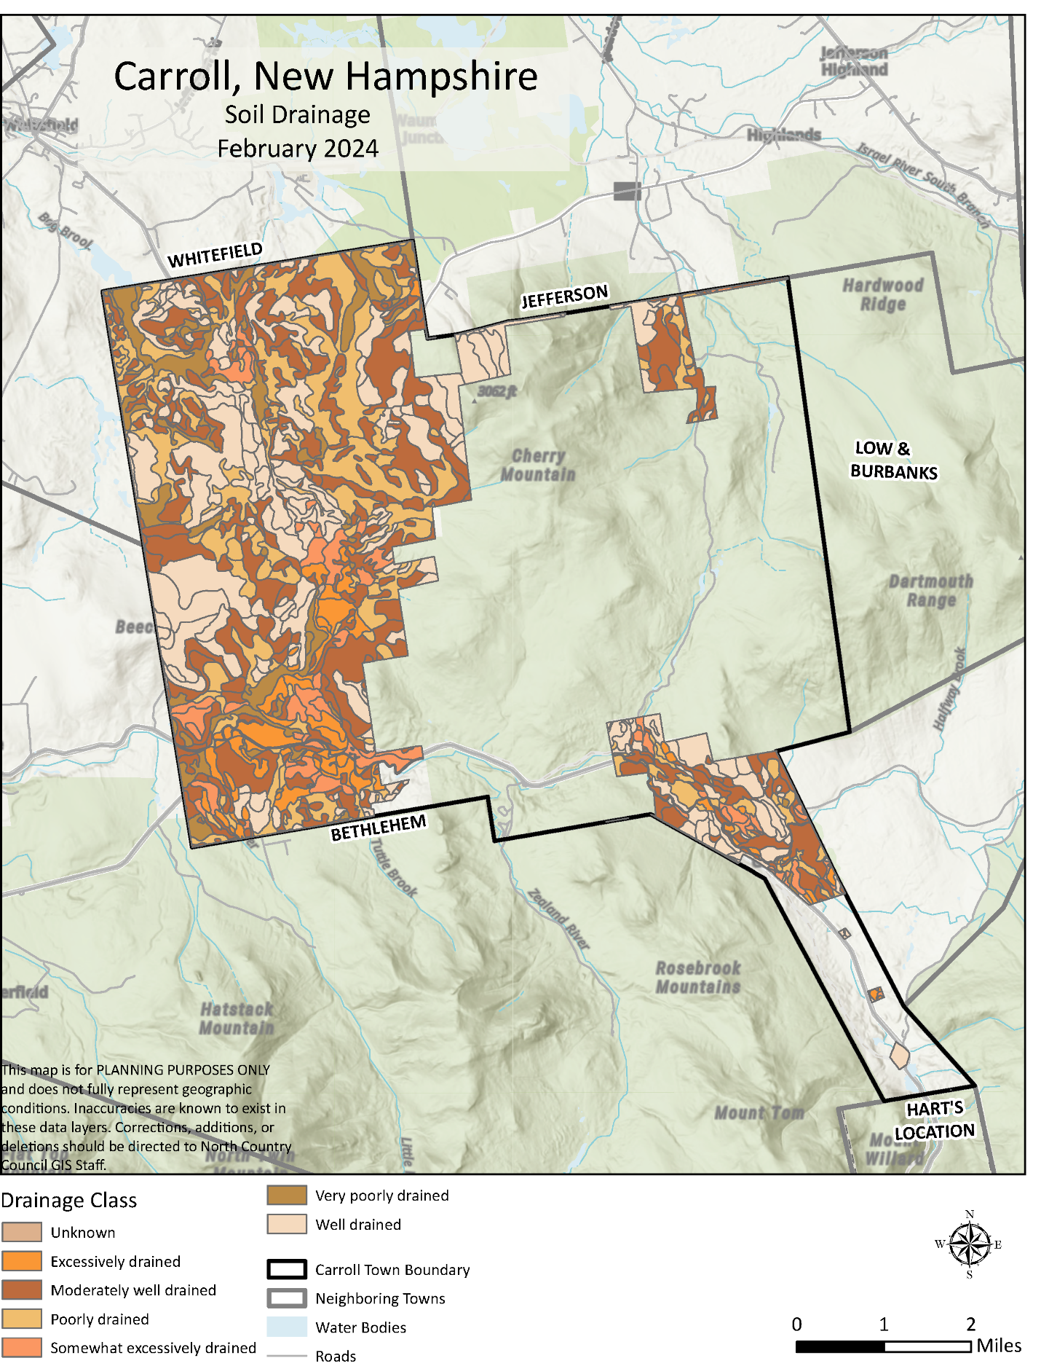
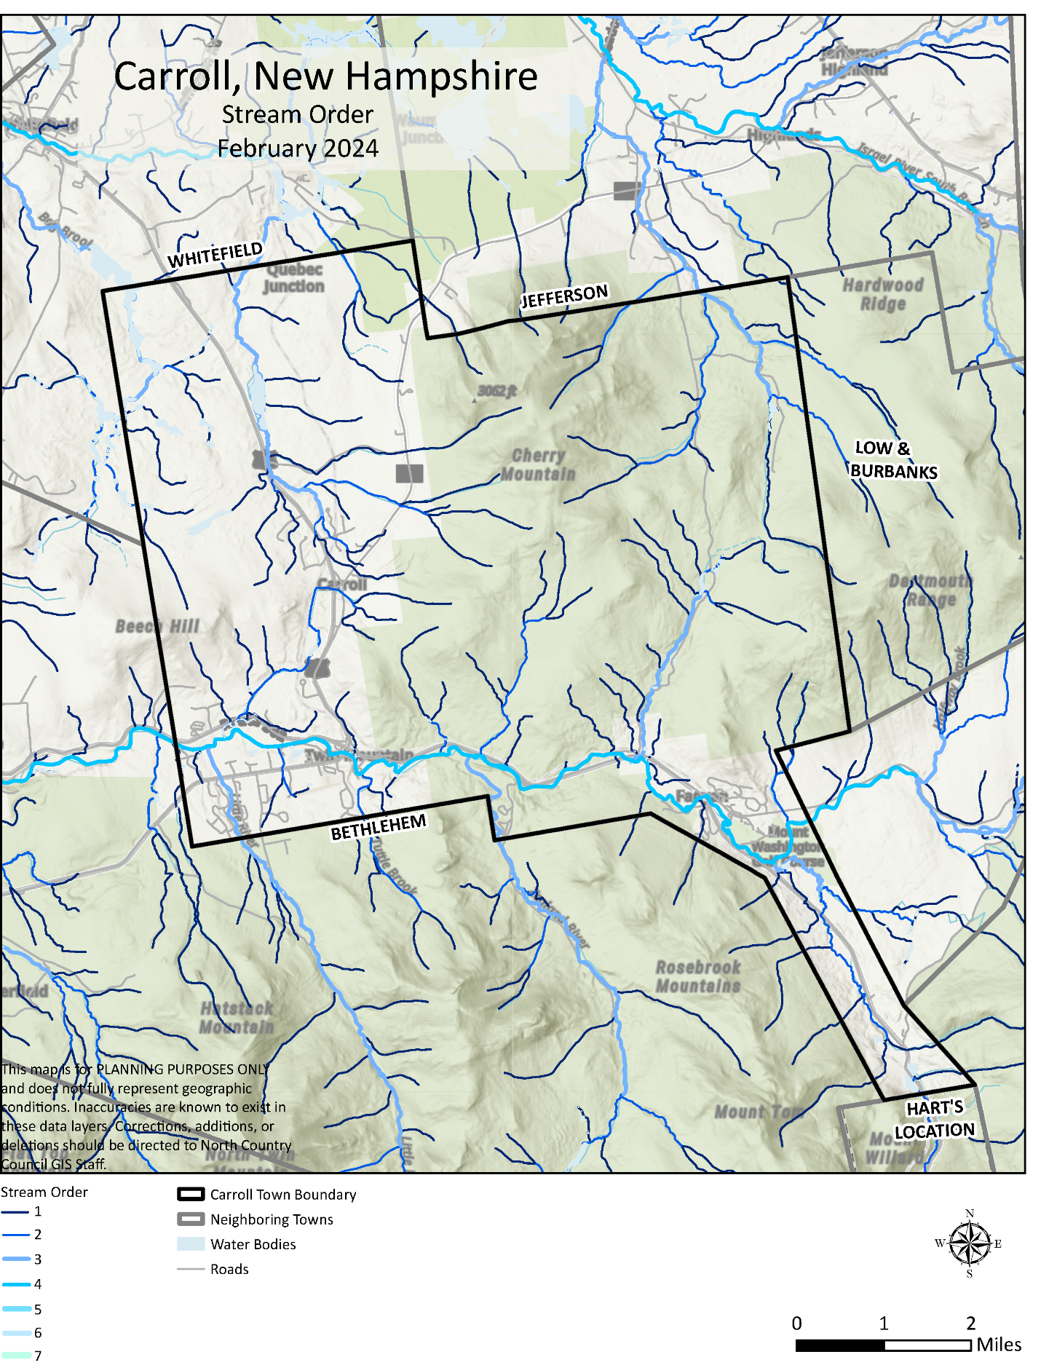
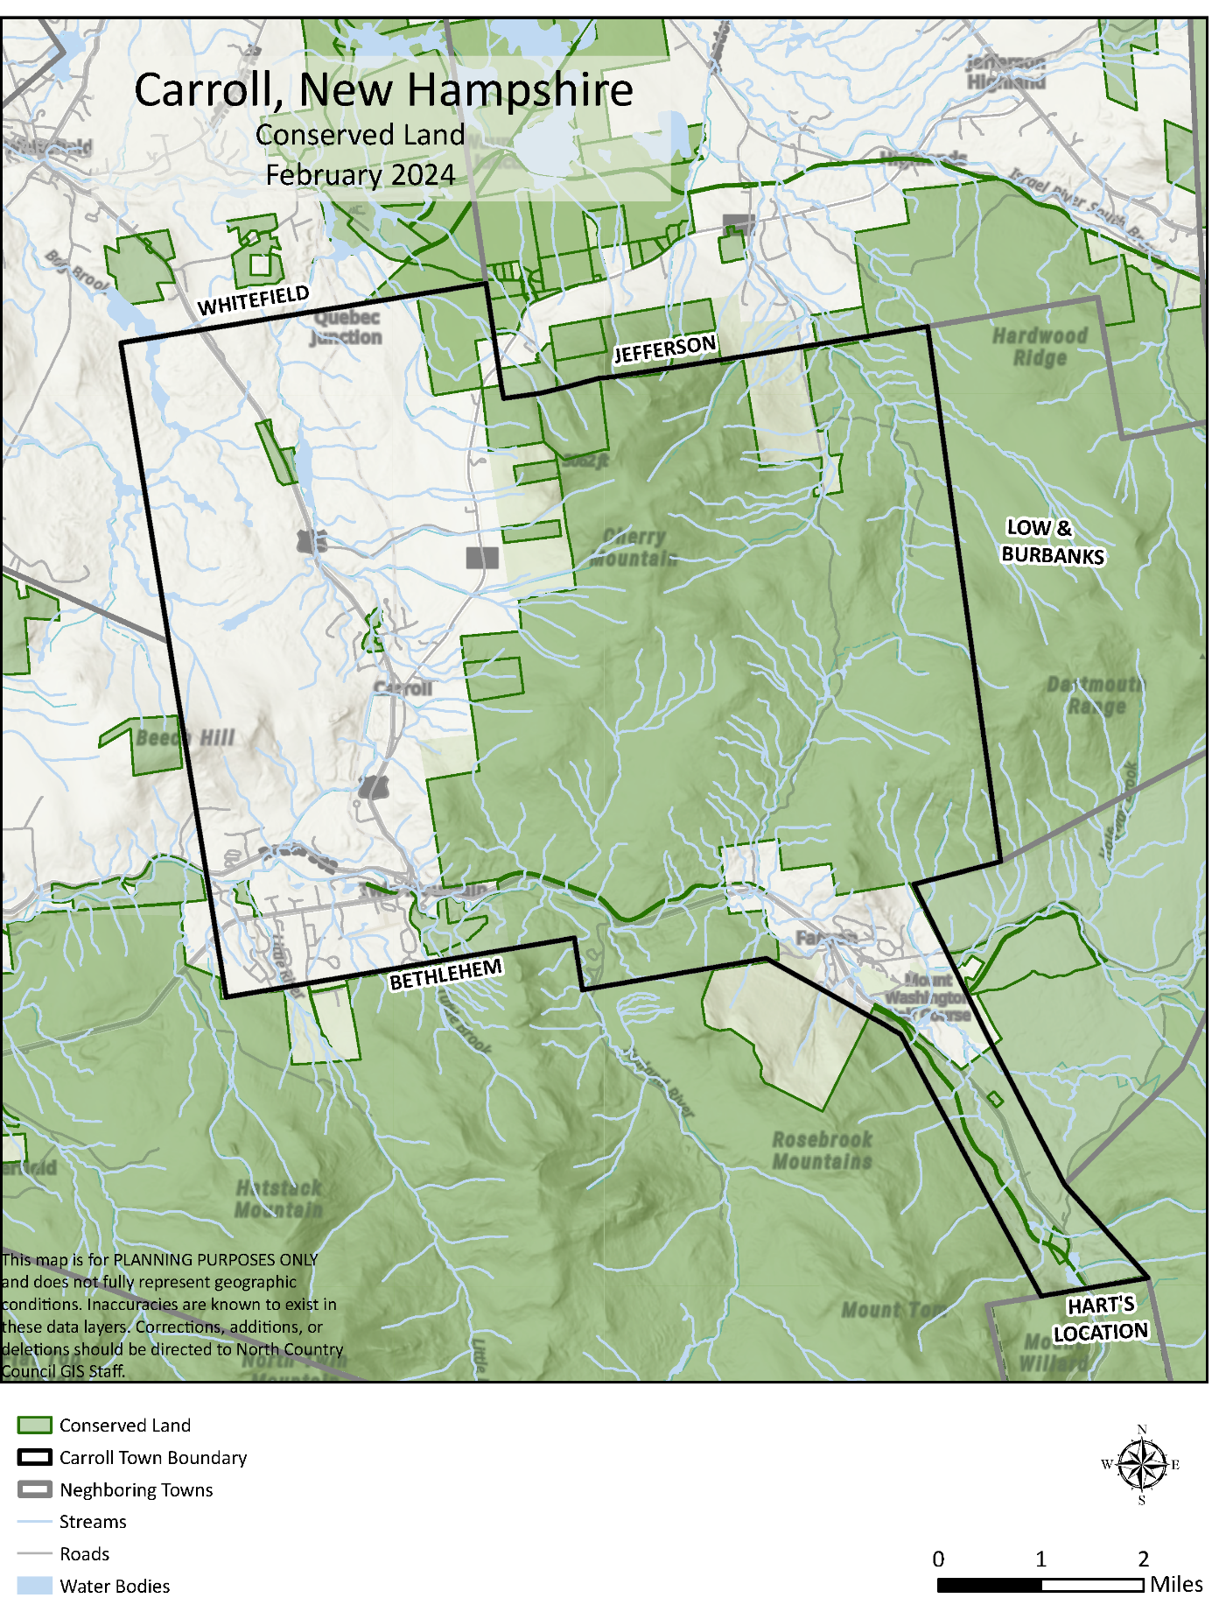

Appendix C – Resident Survey Response

https://housingforwardva.org/
NH Housing Finance Authority, 2023 Short-Term Rental Analysis
Carroll, N.H. Zoning Ordinance as Amended March 12, 2019, pg. 2
North Country Council, 2023 Statewide Housing Needs Assessment
North Country Council, 2023 Statewide Housing Needs Assessment, pg.55
Town of Carroll, 2024 Town Report: https://carrollnh.org/
Town of Carroll, Town Report, 2024
USDA, Visitor Report for White Mountain National Forest, Updated January 2025
NH Department of Revenue Administration, Municipal and Property Division, Current Use Report, 2023
https://www.augurisk.com/risk/state/new-hampshire/carroll/33003
NH Land Conservation Report, Society for the Protection of New Hampshire’s Forests, https://www.forestsociety.org/advocacy-issue/nh-land-conservation-report
University of New Hampshire, Newsroom article from January 9, 2017: https://www.unh.edu/unhtoday/news/release/2017/01/09/unh-research-some-bats-develop-resistance-devastating-fungal-disease
University of New Hampshire, Newsroom Article from April 9, 2019. https://www.unh.edu/unhtoday/news/release/2019/04/09/unh-researchers-reveal-more-dozen-wild-bee-species-declining-northeast

